**Tugas Besar Desain Web**

***“Website Blog Perusahaan Mobil”***



Dosen :

**Adi Wahyu Pribadi, S.Si., M.Kom.**

Disusun Oleh :

**Mohamad Adlian (4518210062)**

**Bayu Surya Arafah (4520210082)**

**Rafi Syamary (45202100**

**Valiant Benvenuto Gianzuriel (45202100**

**JURUSAN TEKNIK INFORMATIKA**

**FAKULTAS TEKNIK**

**UNIVERSITAS PANCASILA**

**JAKARTA SELATAN**

**2019/2020**

**KATA PENGANTAR**

Segala puji panjatkan ke hadirat Allah SWT atas segala rahmat dan karunia yang diberikan, penyusun dapat menyelesaikan laporan tentang “Tugas Besar” pada mata kuliah Desain Web.

Dalam penyusunan laporan ini, penyususn mengucapkan terima kasih sebesar-besarnya kepada :

1. Bapak Adi Wahyu Pribadi, S.Si., M.Kom. selaku dosen pengampu mata kuliah Desain Web
2. Asisten Praktikum Desain Web

penyusun menyadari bahwa laporan praktikum ini masih banyak kekurangan. Untuk itu, kami dengan sangat terbuka menerima kritik dan saran dari pembaca sekalian. Semoga laporan praktikum ini bermanfaat untuk kita semua.

Terima kasih.

Jakarta, 06 Januari 2020

Penyusun

Mohamad Adlian

**DAFTAR ISI**

Kata Pengantar…………………………………………………………………....1

Daftar Isi………………………………………………………………………….2

BAB I……………………………………………………………………………. 3

-PENDAHULUAN……………………………………………………………….3

I.1Latar Belakang…………………………………………………………3

I.2Tujuan………………………………………………………………….4

BAB II …………………………………………………………………………… 5

- PEMBAHASAN………………………………………………………………. ..5

II.1Tugas Besar……………………………………………………………5

II.2 Menu Utama/*Index* …………………………………………………...6

II.3 Menu Menu Car…………..………………………………………….10

* 1. Menu Sportcar ……………………………….........................10
  2. Menu Hypercar ………………………………………….......25

II.4 Menu About Us………...……………………………………………36

II.5 Menu Login …………………………………………………………40

II.6 *Style.css* ……………………………………………………………..42

II.7 Lowongan Kerja…………………………………………………… .46

BAB III ………………………………………………………………………….78

- PENUTUP ……………………………………………………………………..78

III.1 Kesimpulan ………………………………………………………...78

**BAB I**

**PENDAHULUAN**

**I.1 Latar Belakang**

Perkembangan teknologi di dunia Website ini semakin pesat dan tidak terbatas. Hal ini ditandai dengan maraknya produsen yang mulai mengunakan website tidak hanya sebagai media untuk mengiklankan sesuatu, tetapi juga untuk memenuhi segala kebutuhannya, mulai dari kebutuhan di bidang Industri, Kepolisian, Pendidikan sampai kebutuhan Rumah tangga. Banyaknya Website-website yang telah diciptakan membutikan bahwa banyaknya persaingan di bidang Web. Setiap Web Designer dan Web Programmer saling berlomba dalam menciptakan inovasi baru dibidang web. Pembuatan Web itu sendiri merupakan perpaduan antara sintak HTML, MYSQL, JavaScript dengan PHP MyAdmin dan lain sebagainya. Perkembangan website sekarang ini bukan lagi menjadi kendala yang sulit di dapatkan dan terbatas, tetapi dikalangan pelajar dan mahasiswa juga ikut andil dalam penelitian dan pembuatannya. Dari hal tersebut banyak berbagai website yang dapat diciptakan mulai dari web profile pribadi maupun profile perusahaan,web penjualan(e-commerce), web portal(news), iklan baris(advertising) dan khususnya website blog. Dengan berkembangnya website tersebut sebuah komunitas fotografi di Indonesia membentuk sebuah budaya komunikasi yang baru di masyarakat.

Berdasarkan uraian singkat diatas penulis tertarik untuk membuat website berbasis blog unutk memberikan pengetahuan mengenai informasi yang di butuhkan oleh masyarakat dan untuk itu judul tugas besar desain web ini adalah

“ Website Blog Perusahaan Mobil”.

**I.2 Tujuan**

Tujuan dari pembuatan desain web ini adalah :

1. Memberikan informasi mobil terhadap pengguna.
2. Membantu para pengguna untuk membeli mobil.
3. Mengembangkan website berbasi blog perusahaan mobil.

**BAB II**

**Pembahasan**

**II.1 Tugas Besar**

**Penjelasan Website**

Website ini mendeskripsikan tentang blog sebuah perusahaan yang menampilkan informasi tentang mobil dari perusahaan McLaren yang dijual di Indonesia. Dengan adanya website ini para pengakses mendapatkan informasi mengenai mobil tertentu dari sportcar hingga hypercar dan di website ini juga menampilkan harga dari mobil tersebut.

**Penjelasan Referensi**

Referensi web ini berdasarkan web starbucks.com dan cars.mclaren.com. Referensi web ini diambil dikarenakan webnya yang indah dan juga sangat rapih sehingga para pengakses mendapatkan informasi dengan mudah. Website Starbucks terdapat menu navigasi yang lengkap da nisi nya juga bermanfaat. Di website mclaren terdapat menu login untuk para pengguna.

**II.2 Menu Utama/ Index**

Tampilan utama menu index

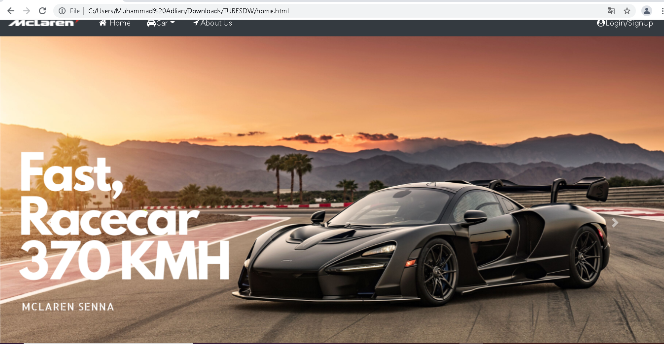

**Codingan home.html**

<!DOCTYPE html>

<html lang=”en”>

<head >

<meta charset=”UTF-8”>

<meta name=”viewport” content=”width=device-width, initial-scale=1.0”>

<meta http-equiv=”X-UA-Compatible” content=”ie=edge”>

<title>Welcome To Mclaren</title>

<link rel=”stylesheet” href=”css/style.css”>

<link rel=”stylesheet” href=”css/bootstrap.css”>

<!—Icon🡪

<link rel=”stylesheet” href=”https://cdnjs.cloudflare.com/ajax/libs/font-awesome/4.7.0/css/font-awesome.min.css”>

<!—Memakai jQuery 🡪

<script src=”https://code.jquery.com/jquery-3.4.1.min.js”

integrity=”sha256-CSXorXvZcTkaix6Yvo6HppcZGetbYMGWSFlBw8HfCJo=”crossorigin=”anonymous”></script>

<!—Popper JS 🡪

<script src=”https://cdnjs.cloudflare.com/ajax/libs/popper.js/1.14.7/umd/popper.min.js”></script>

<!—Latest compiled JavaScript 🡪

<script src=”https://maxcdn.bootstrapcdn.com/bootstrap/4.3.1/js/bootstrap.min.js”></script>

<script src=”https://ajax.googleapis.com/ajax/libs/jquery/3.4.1/jquery.min.js”></script>

<script src=”https://maxcdn.bootstrapcdn.com/bootstrap/3.4.1/js/bootstrap.min.js”></script>

</head>

<body style=”background-image: url(images/race1.jpg); “>

<header>

<nav class=”navbar navbar-expand-md navbar-dark bg-dark”>

<a class=”navbar-brand” href=”home.html”>

<img src=”images/logo2.png” width=”150” class=”d-inline-block align-top” alt=””>

</a>

<button class=”navbar-toggler” type=”button” data-toggle=”collapse” data-target=”#navbarNav” aria-controls=”navbarNav” aria-expanded=”false” aria-label=”Toggle navigation”>

<span class=”navbar-toggler-icon”></span>

</button>

<div class=”collapse navbar-collapse “ id=”navbarNav”>

<ul class=”nav”>

<li class=”nav-item”>

<a class=”nav-link” href=”home.html”><i class=”fa fa-fw fa-home”></i> Home <span class=”sr-only”>(current)</span></a>

</li>

<li class=”nav-item dropdown”>

<a class=”nav-link dropdown-toggle” href=”#” id=”navbardrop” data-toggle=”dropdown” role=”button” aria-haspopup=”true” aria-expanded=”false”><i class=”fa fa-fw fa-car”></i>Car</a>

<div class=”dropdown-menu”>

<a class=”dropdown-item” href=”hyper.html”> Hyper Car</a>

<a class=”dropdown-item” href=”sports.html”> Sports Car</a>

</div>

</li>

<li class=”nav-item”>

<a class=”nav-link” href=”about.html”><i class=”fa fa-fw fa-location-arrow”></i>About Us</a>

</li>

</ul>

<div class=”navbar-nav ml-auto “>

<a href=”Login.html” class=”nav-item nav-link” style=”color:white;” ><i class=”fa fa-fw fa-user-circle”></i>Login/SignUp</a>

</div>

</ul>

</div>

</nav>

</div>

</header>

<article>

<div id=”carouselExampleFade” class=”carousel slide carousel-fade “ data-ride=”carousel”>

<div class=”carousel-inner”>

<div class=”carousel-item active”>

<img class=”d-block w-100” src=”images/senna2.png” height=”100%” width=”100%”

alt=”First slide”>

</div>

<div class=”carousel-item”>

<img class=”d-block w-100” src=”images/senna3.png” height=”100%” width=”100%”

alt=”Second slide”>

</div>

</div>

<a class=”carousel-control-prev” href=”#carouselExampleFade” role=”button” data-slide=”prev”>

<span class=”carousel-control-prev-icon” aria-hidden=”true”></span>

<span class=”sr-only”>Previous</span>

</a>

<a class=”carousel-control-next” href=”#carouselExampleFade” role=”button” data-slide=”next”>

<span class=”carousel-control-next-icon” aria-hidden=”true”></span>

<span class=”sr-only”>Next</span>

</a>

</div>

</article>

<div class=”img”>

<img src=”images/p1.png” height=”100%” width=”100%” alt=””>

</div>

<!—Footer 🡪

<footer id=”myFooter”>

<div class=”container-fluid”>

<div class=”row text-center”>

<div class=”col-12 col-sm-6 col-md-3”>

<h1 class=”logo” style=”margin-top:30px;”></h1><img src=”images/logo2.png” width=”200px” >&nbsp;&nbsp;</img></h1>

</div>

<div class=”col-12 col-sm-6 col-md-2”>

<h5>Get started</h5>

<ul>

<li><a href=”home.html”>Home</a></li>

<li><a href=”Login.html”>Login</a></li>

</ul>

</div>

<div class=”col-12 col-sm-6 col-md-2”>

<h5>Our Company</h5>

<ul>

<li><a href=”about.html”>About Us</a></li>

</ul>

</div>

<div class=”col-md-3 social-networks”>

<div></div><a href=”#” class=”facebook”><i class=”fa fa-facebook”></i></a><a href=”#” class=”twitter”><i class=”fa fa-twitter”></i></a><a href=”#”></i></a>

<a href=”about.html”><button class=”btn btn-primary” type=”button” style=”margin-top:20px;”>Contact us</button></a>

</div>

</div>

<div class=”row footer-copyright”>

<div class=”col”>

<p>© 2016 Copyright McLaren &nbsp;<a href=”#”>Mohamad Adlian</a></p>

</div>

</div>

</div>

</footer>

</body>

</html>

**II.3 Menu Menu Car**

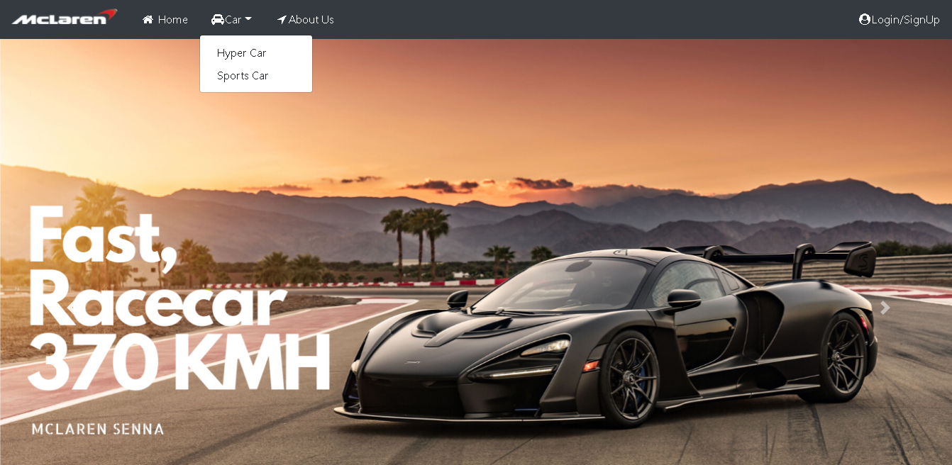

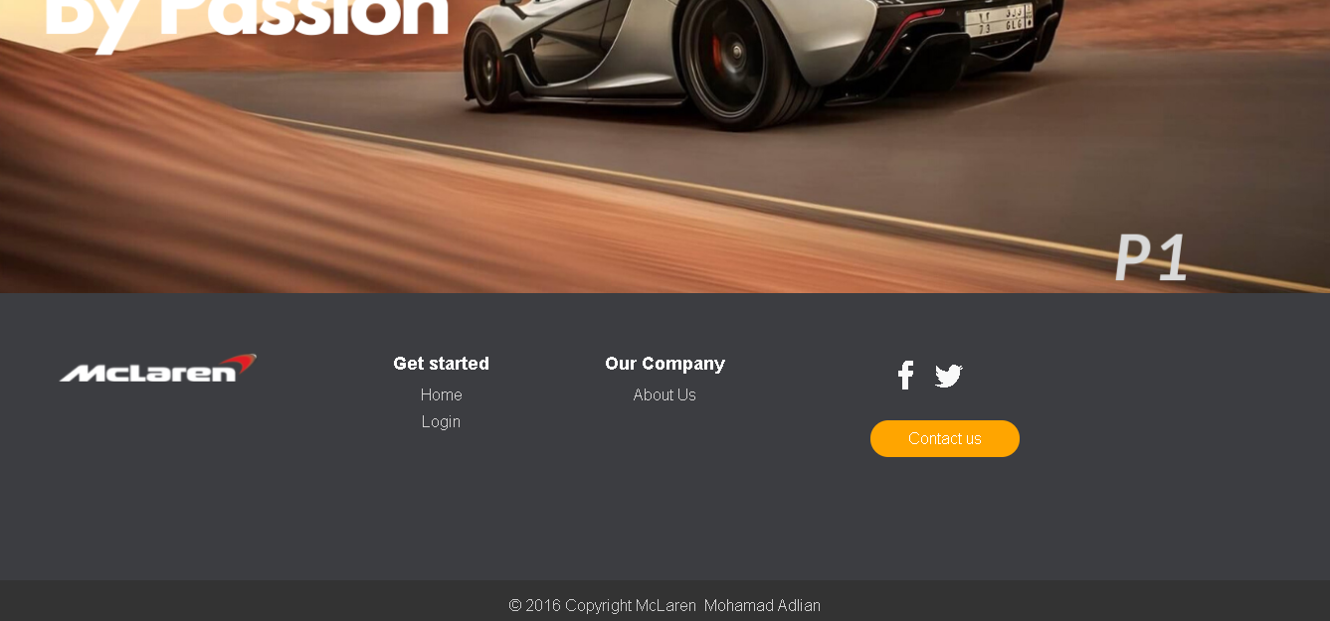

**3.1 Menu Sportscar**

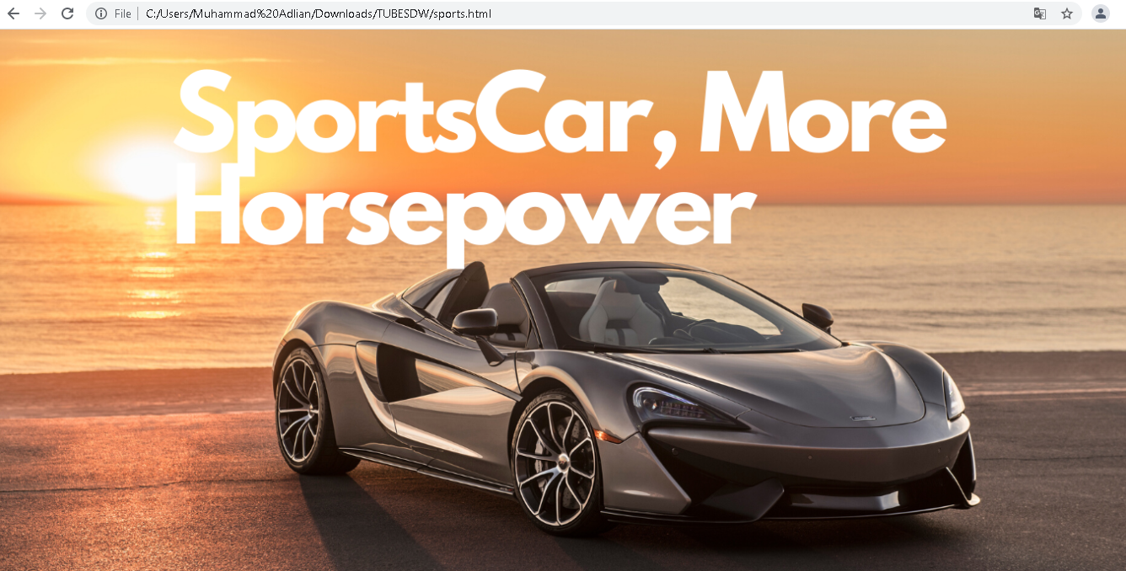

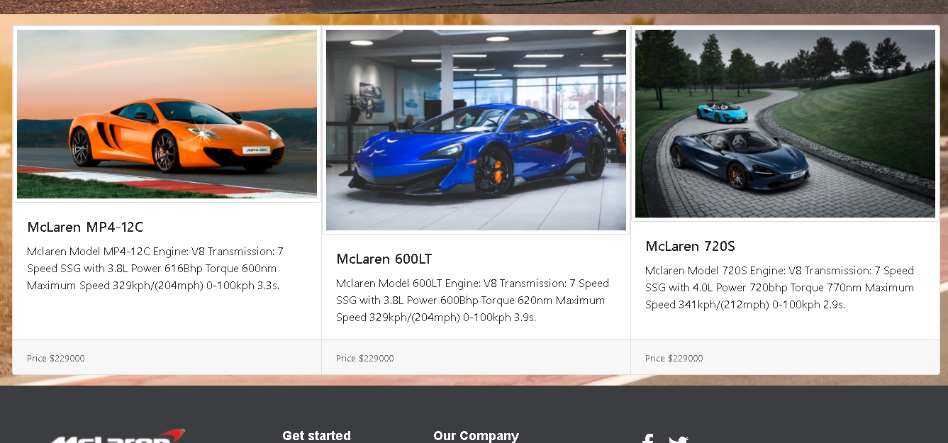

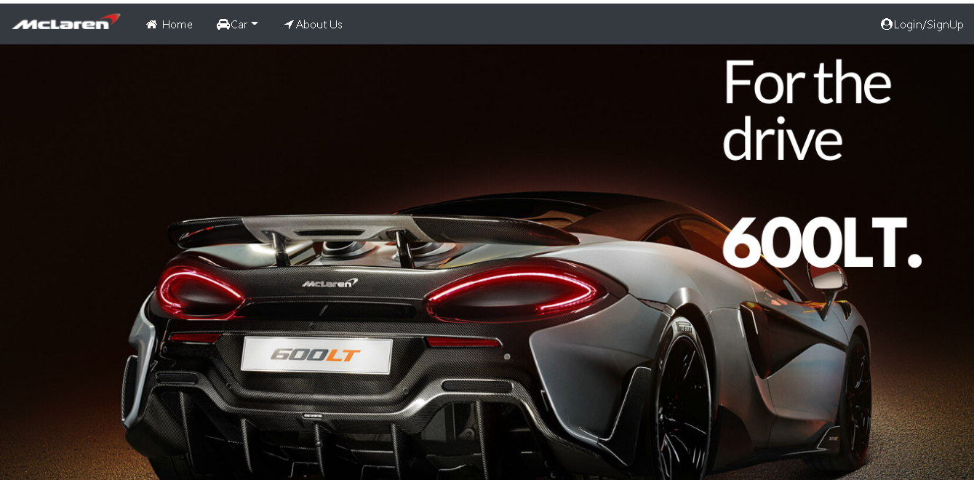

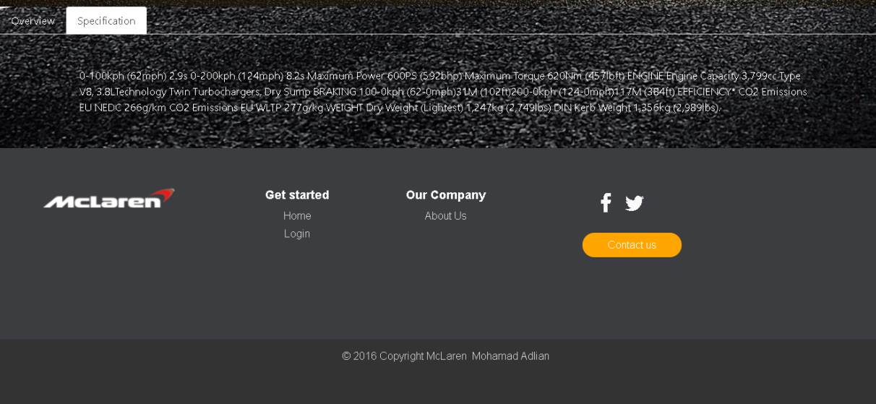

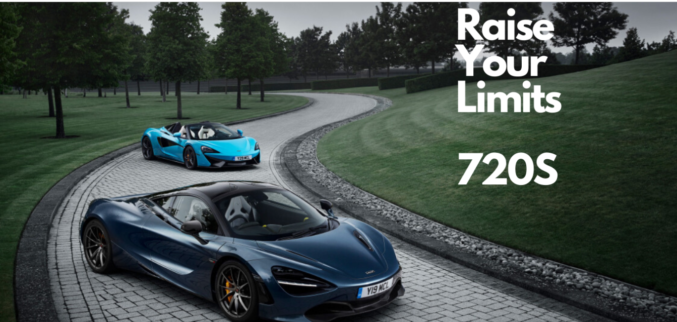

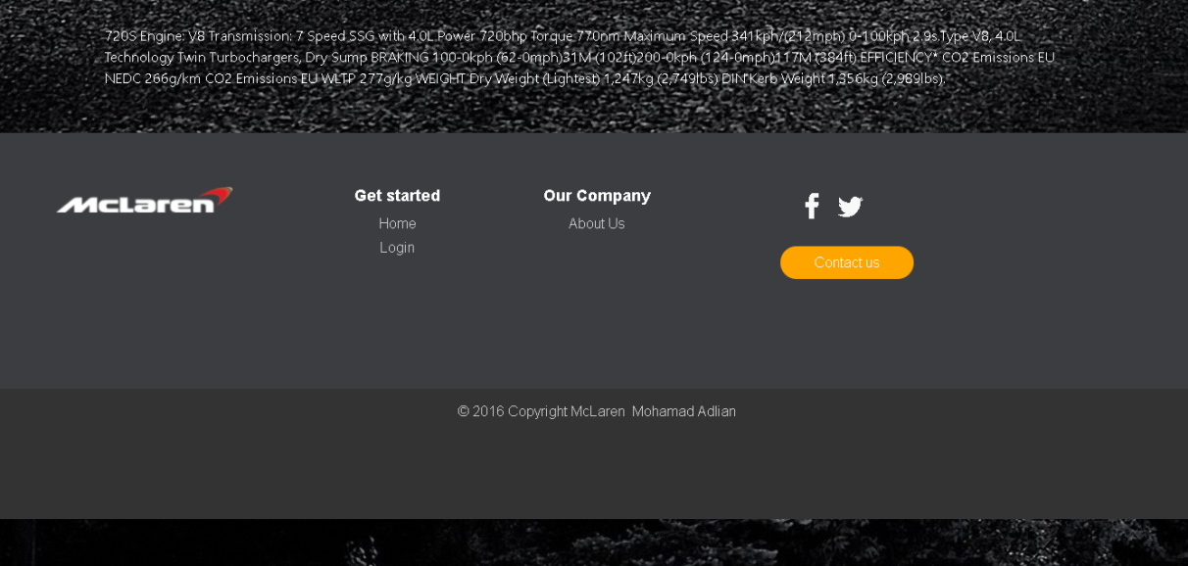

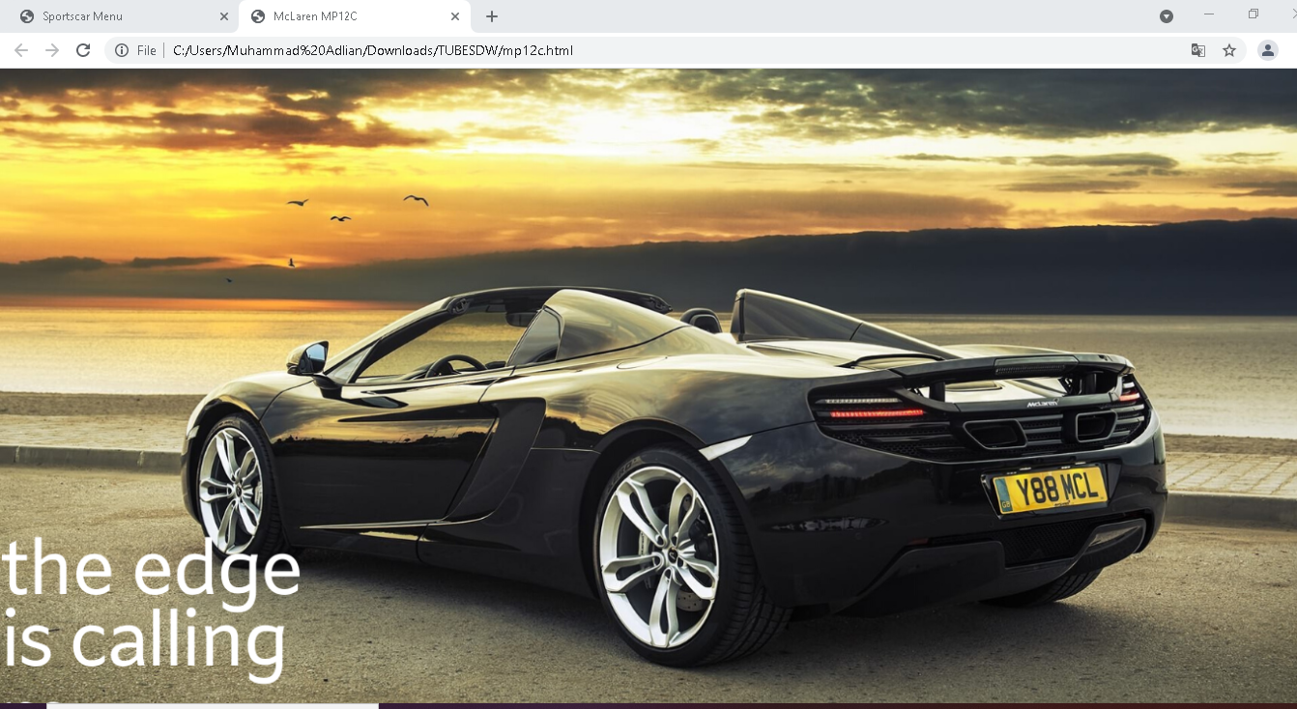

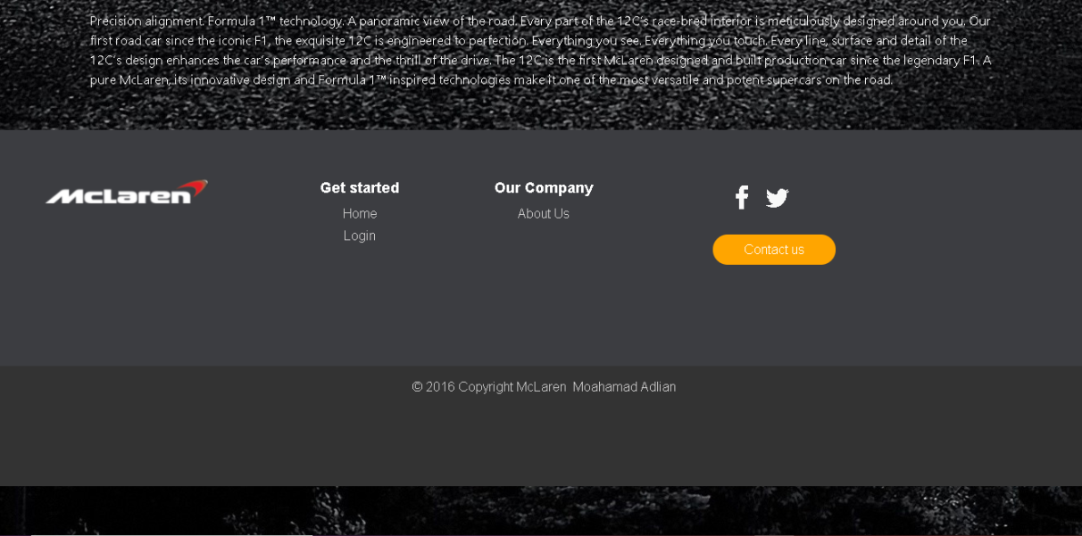

**Codingan sportscar.html**

<!DOCTYPE html>

<html lang=”en”>

<head>

<meta charset=”UTF-8”>

<meta name=”viewport” content=”width=device-width, initial-scale=1.0”>

<meta http-equiv=”X-UA-Compatible” content=”ie=edge”>

<title>Sportscar Menu</title>

<link rel=”stylesheet” href=”css/style.css”>

<link rel=”stylesheet” href=”css/bootstrap.css”>

<!—Icon🡪

<link rel=”stylesheet” href=”https://cdnjs.cloudflare.com/ajax/libs/font-awesome/4.7.0/css/font-awesome.min.css”>

<!—Memakai jQuery 🡪

<script src=”https://code.jquery.com/jquery-3.4.1.min.js”

integrity=”sha256-CSXorXvZcTkaix6Yvo6HppcZGetbYMGWSFlBw8HfCJo=”crossorigin=”anonymous”></script>

<!—Popper JS 🡪

<script src=”https://cdnjs.cloudflare.com/ajax/libs/popper.js/1.14.7/umd/popper.min.js”></script>

<!—Latest compiled JavaScript 🡪

<script src=”https://maxcdn.bootstrapcdn.com/bootstrap/4.3.1/js/bootstrap.min.js”></script>

<script src=”https://ajax.googleapis.com/ajax/libs/jquery/3.4.1/jquery.min.js”></script>

<script src=”https://maxcdn.bootstrapcdn.com/bootstrap/3.4.1/js/bootstrap.min.js”></script>

</head>

<body style=”background-image: url(images/senna.jpg);”>

<header>

<nav class=”navbar navbar-expand-md navbar-dark bg-dark “>

<a class=”navbar-brand” href=”home.html”>

<img src=”images/logo2.png” width=”150” class=”d-inline-block align-top” alt=””>

</a>

<button class=”navbar-toggler” type=”button” data-toggle=”collapse” data-target=”#navbarNav” aria-controls=”navbarNav” aria-expanded=”false” aria-label=”Toggle navigation”>

<span class=”navbar-toggler-icon”></span>

</button>

<div class=”collapse navbar-collapse “ id=”navbarNav”>

<ul class=”nav”>

<li class=”nav-item”>

<a class=”nav-link” href=”home.html”><i class=”fa fa-fw fa-home”></i> Home <span class=”sr-only”>(current)</span></a>

</li>

<li class=”nav-item dropdown”>

<a class=”nav-link dropdown-toggle” href=”#” id=”navbardrop” data-toggle=”dropdown” role=”button” aria-haspopup=”true” aria-expanded=”false” ><i class=”fa fa-fw fa-car”></i>Car</a>

<div class=”dropdown-menu”>

<a class=”dropdown-item” href=”hyper.html”> Hyper Car</a>

<a class=”dropdown-item” href=”#”> Sports Car</a>

</div>

</li>

<li class=”nav-item”>

<a class=”nav-link” href=”about.html”><i class=”fa fa-fw fa-location-arrow”></i>About Us</a>

</li>

</ul>

<div class=”navbar-nav ml-auto “>

<a href=”Login.html” class=”nav-item nav-link” style=”color:white;” ><i class=”fa fa-fw fa-user-circle”></i>Login/SignUp</a>

</div>

</ul>

</div>

</nav>

</div>

</header>

<div class=”img”>

<img src=”images/sports.png” height=”100%” width=”100%” alt=””>

</div>

<article>

<div class=”card-group”>

<div class=”card”>

<a target=”#” href=”mp12c.html”> <img src=”images/mp12c.jpg” class=”card-img-top “ alt=” McLaren mp12c” ></a>

<div class=”card-body”>

<h5 class=”card-title”>McLaren MP4-12C</h5>

<p class=”card-text”>Mclaren Model MP4-12C Engine: V8 Transmission: 7 Speed SSG with 3.8L Power 616Bhp Torque 600nm Maximum Speed 329kph/(204mph) 0-100kph 3.3s.</p>

</div>

<div class=”card-footer”>

<small class=”text-muted”>Price $229000</small>

</div>

</div>

<div class=”card”>

<a target=”3” href=”600lt.html”><img src=”images/600lt.jpg” class=”card-img-top “ alt=” McLaren 600LT” ></a>

<div class=”card-body”>

<h5 class=”card-title”>McLaren 600LT</h5>

<p class=”card-text”>Mclaren Model 600LT Engine: V8 Transmission: 7 Speed SSG with 3.8L Power 600Bhp Torque 620nm Maximum Speed 329kph/(204mph) 0-100kph 3.9s.</p>

</div>

<div class=”card-footer”>

<small class=”text-muted”>Price $229000</small>

</div>

</div>

<div class=”card”>

<a target=”#” href=”720s.html”><img src=”images/720s.jpg” class=”card-img-top “ alt=” McLaren 720S” ></a>

<div class=”card-body”>

<h5 class=”card-title”>McLaren 720S</h5>

<p class=”card-text”>Mclaren Model 720S Engine: V8 Transmission: 7 Speed SSG with 4.0L Power 720bhp Torque 770nm Maximum Speed 341kph/(212mph) 0-100kph 2.9s.</p>

</div>

<div class=”card-footer”>

<small class=”text-muted”>Price $229000</small>

</div>

</div>

</article>

<!—Footer 🡪

<footer id=”myFooter”>

<div class=”container-fluid”>

<div class=”row text-center”>

<div class=”col-12 col-sm-6 col-md-3”>

<h1 class=”logo” style=”margin-top:30px;”></h1><img src=”images/logo2.png” width=”200px” >&nbsp;&nbsp;</img></h1>

</div>

<div class=”col-12 col-sm-6 col-md-2”>

<h5>Get started</h5>

<ul>

<li><a href=”home.html”>Home</a></li>

<li><a href=”Login.html”>Login</a></li>

</ul>

</div>

<div class=”col-12 col-sm-6 col-md-2”>

<h5>Our Company</h5>

<ul>

<li><a href=”about.html”>About Us</a></li>

</ul>

</div>

<div class=”col-md-3 social-networks”>

<div></div><a href=”#” class=”facebook”><i class=”fa fa-facebook”></i></a><a href=”#” class=”twitter”><i class=”fa fa-twitter”></i></a><a href=”#”></i></a>

<a href=”about.html”><button class=”btn btn-primary” type=”button” style=”margin-top:20px;”>Contact us</button></a>

</div>

</div>

<div class=”row footer-copyright”>

<div class=”col”>

<p>© 2016 Copyright McLaren &nbsp;<a href=”#”>Reza Septa Fabian</a></p>

</div>

</div>

</div>

</footer>

</body>

</body>

</html>

**Codingan menu mobil mp12c**

<!DOCTYPE html>

<html lang=”en”>

<head>

<meta charset=”UTF-8”>

<meta name=”viewport” content=”width=device-width, initial-scale=1.0”>

<meta http-equiv=”X-UA-Compatible” content=”ie=edge”>

<title>McLaren MP12C</title>

<link rel=”stylesheet” href=”css/style.css”>

<link rel=”stylesheet” href=”css/bootstrap.css”>

<!—Icon🡪

<link rel=”stylesheet” href=”https://cdnjs.cloudflare.com/ajax/libs/font-awesome/4.7.0/css/font-awesome.min.css”>

<!—Memakai jQuery 🡪

<script src=”https://code.jquery.com/jquery-3.4.1.min.js”

integrity=”sha256-CSXorXvZcTkaix6Yvo6HppcZGetbYMGWSFlBw8HfCJo=”crossorigin=”anonymous”></script>

<!—Popper JS 🡪

<script src=”https://cdnjs.cloudflare.com/ajax/libs/popper.js/1.14.7/umd/popper.min.js”></script>

<!—Latest compiled JavaScript 🡪

<script src=”https://maxcdn.bootstrapcdn.com/bootstrap/4.3.1/js/bootstrap.min.js”></script>

<script src=”https://ajax.googleapis.com/ajax/libs/jquery/3.4.1/jquery.min.js”></script>

<script src=”https://maxcdn.bootstrapcdn.com/bootstrap/3.4.1/js/bootstrap.min.js”></script>

</head>

<body style=”background-image: url(images/race1.jpg);”>

<header>

<nav class=”navbar navbar-expand-md navbar-dark bg-dark “>

<a class=”navbar-brand” href=”home.html”>

<img src=”images/logo2.png” width=”150” class=”d-inline-block align-top” alt=””>

</a>

<button class=”navbar-toggler” type=”button” data-toggle=”collapse” data-target=”#navbarNav” aria-controls=”navbarNav” aria-expanded=”false” aria-label=”Toggle navigation”>

<span class=”navbar-toggler-icon”></span>

</button>

<div class=”collapse navbar-collapse “ id=”navbarNav”>

<ul class=”nav”>

<li class=”nav-item”>

<a class=”nav-link” href=”home.html”><i class=”fa fa-fw fa-home”></i> Home <span class=”sr-only”>(current)</span></a>

</li>

<li class=”nav-item dropdown”>

<a class=”nav-link dropdown-toggle” href=”#” id=”navbardrop” data-toggle=”dropdown” role=”button” aria-haspopup=”true” aria-expanded=”false”></i>Car</a>

<div class=”dropdown-menu”>

<a class=”dropdown-item” href=”hyper.html”> Hyper Car</a>

<a class=”dropdown-item” href=”sports.html”> Sports Car</a>

</div>

</li>

<li class=”nav-item”>

<a class=”nav-link” href=”about.html”><i class=”fa fa-fw fa-location-arrow”></i>About Us</a>

</li>

</ul>

<div class=”navbar-nav ml-auto “>

<a href=”Login.html” class=”nav-item nav-link” style=”color:white;” ><i class=”fa fa-fw fa-user-circle”></i>Login/SignUp</a>

</div>

</ul>

</div>

</nav>

</div>

</header>

<div class=”img”>

<img src=”images/mp14.png” height=”100%” width=”100%” alt=””>

</div>

<article>

<!—Nav tabs 🡪

<ul class=”nav nav-tabs”>

<li class=”nav-item”>

<a class=”nav-link active” data-toggle=”tab” href=”#Overview”>Overview</a>

</li>

<li class=”nav-item”>

<a class=”nav-link” data-toggle=”tab” href=”#Specification”>Specification</a>

</li>

</ul>

<!—Tab panes 🡪

<div class=”tab-content”>

<div class=”tab-pane container active” id=”Overview”>Precision alignment. Formula 1™ technology. A panoramic view of the road. Every part of the 12C’s race-bred interior is meticulously designed around you.

Our first road car since the iconic F1, the exquisite 12C is engineered to perfection. Everything you see. Everything you touch. Every line, surface and detail of the 12C’s design enhances the car’s performance and the thrill of the drive.

The 12C is the first McLaren designed and built production car since the legendary F1. A pure McLaren, its innovative design and Formula 1™ inspired technologies make it one of the most versatile and potent supercars on the road.

</div>

<div class=”tab-pane container fade” id=”Specification”> PERFORMANCE

Maximum Speed 333kph (207mph) 0-100kph (62mph) 3.1s 0-200kph (124mph) 8.8s Maximum Power 625PS (616bhp) Maximum Torque,600Nm (443lbft) ENGINE Engine Capacity 3,799cc Type V8, 4.0L Technology Twin Turbochargers, Dry Sump BRAKING 100-0kph (62-0mph) 30.7m (101ft) 200-0kph (124-0mph) 123.5m (405ft) EFFICIENCY* CO2 Emissions EU WLTP 279g/km WEIGHT Dry Weight (Lightest) 1,341kg (2,956lb) DIN Kerb Weight 1,474kg (3,249lbs).</div>

</div>

</article>

<!—Footer 🡪

<footer id=”myFooter”>

<div class=”container-fluid”>

<div class=”row text-center”>

<div class=”col-12 col-sm-6 col-md-3”>

<h1 class=”logo” style=”margin-top:30px;”></h1><img src=”images/logo2.png” width=”200px” >&nbsp;&nbsp;</img></h1>

</div>

<div class=”col-12 col-sm-6 col-md-2”>

<h5>Get started</h5>

<ul>

<li><a href=”home.html”>Home</a></li>

<li><a href=”Login.html”>Login</a></li>

</ul>

</div>

<div class=”col-12 col-sm-6 col-md-2”>

<h5>Our Company</h5>

<ul>

<li><a href=”about.html”>About Us</a></li>

</ul>

</div>

<div class=”col-md-3 social-networks”>

<div></div><a href=”#” class=”facebook”><i class=”fa fa-facebook”></i></a><a href=”#” class=”twitter”><i class=”fa fa-twitter”></i></a><a href=”#”></i></a>

<a href=”about.html”><button class=”btn btn-primary” type=”button” style=”margin-top:20px;”>Contact us</button></a>

</div>

</div>

<div class=”row footer-copyright”>

<div class=”col”>

<p>© 2016 Copyright McLaren &nbsp;<a href=”#”>Reza Septa Fabian</a></p>

</div>

</div>

</div>

</footer>

</body>

</body>

</html>

**600lt**

<!DOCTYPE html>

<html lang=”en”>

<head>

<meta charset=”UTF-8”>

<meta name=”viewport” content=”width=device-width, initial-scale=1.0”>

<meta http-equiv=”X-UA-Compatible” content=”ie=edge”>

<title>McLaren 600LT</title>

<link rel=”stylesheet” href=”css/style.css”>

<link rel=”stylesheet” href=”css/bootstrap.css”>

<!—Icon🡪

<link rel=”stylesheet” href=”https://cdnjs.cloudflare.com/ajax/libs/font-awesome/4.7.0/css/font-awesome.min.css”>

<!—Memakai jQuery 🡪

<script src=”https://code.jquery.com/jquery-3.4.1.min.js”

integrity=”sha256-CSXorXvZcTkaix6Yvo6HppcZGetbYMGWSFlBw8HfCJo=”crossorigin=”anonymous”></script>

<!—Popper JS 🡪

<script src=”https://cdnjs.cloudflare.com/ajax/libs/popper.js/1.14.7/umd/popper.min.js”></script>

<!—Latest compiled JavaScript 🡪

<script src=”https://maxcdn.bootstrapcdn.com/bootstrap/4.3.1/js/bootstrap.min.js”></script>

<script src=”https://ajax.googleapis.com/ajax/libs/jquery/3.4.1/jquery.min.js”></script>

<script src=”https://maxcdn.bootstrapcdn.com/bootstrap/3.4.1/js/bootstrap.min.js”></script>

</head>

<body style=”background-image: url(images/race1.jpg);”>

<header>

<nav class=”navbar navbar-expand-md navbar-dark bg-dark “>

<a class=”navbar-brand” href=”home.html”>

<img src=”images/logo2.png” width=”150” class=”d-inline-block align-top” alt=””>

</a>

<button class=”navbar-toggler” type=”button” data-toggle=”collapse” data-target=”#navbarNav” aria-controls=”navbarNav” aria-expanded=”false” aria-label=”Toggle navigation”>

<span class=”navbar-toggler-icon”></span>

</button>

<div class=”collapse navbar-collapse “ id=”navbarNav”>

<ul class=”nav”>

<li class=”nav-item”>

<a class=”nav-link” href=”home.html”><i class=”fa fa-fw fa-home”></i> Home <span class=”sr-only”>(current)</span></a>

</li>

<li class=”nav-item dropdown”>

<a class=”nav-link dropdown-toggle” href=”#” id=”navbardrop” data-toggle=”dropdown” role=”button” aria-haspopup=”true” aria-expanded=”false”><i class=”fa fa-fw fa-car”></i>Car</a>

<div class=”dropdown-menu”>

<a class=”dropdown-item” href=”hyper.html”> Hyper Car</a>

<a class=”dropdown-item” href=”sports.html”> Sports Car</a>

</div>

</li>

<li class=”nav-item”>

<a class=”nav-link” href=”about.html”><i class=”fa fa-fw fa-location-arrow”></i>About Us</a>

</li>

</ul>

<div class=”navbar-nav ml-auto “>

<a href=”Login.html” class=”nav-item nav-link” style=”color:white;” ><i class=”fa fa-fw fa-user-circle”></i>Login/SignUp</a>

</div>

</ul>

</div>

</nav>

</div>

</header>

<div class=”img”>

<img src=”images/600lt2.png” height=”100%” width=”100%” alt=””>

</div>

<article>

<!—Nav tabs 🡪

<ul class=”nav nav-tabs”>

<li class=”nav-item”>

<a class=”nav-link active” data-toggle=”tab” href=”#Overview”>Overview</a>

</li>

<li class=”nav-item”>

<a class=”nav-link” data-toggle=”tab” href=”#Specification”>Specification</a>

</li>

</ul>

<!—Tab panes 🡪

<div class=”tab-content”>

<div class=”tab-pane container active” id=”Overview”>This is the 600LT. The next chapter in the storied history of the McLaren ‘Longtail’. Only the fourth McLaren in two decades to receive the LT – or ‘Longtail’ – name. It lives and breathes the relentless spirit of its ‘Longtail’ predecessors. United by the same singular focus. To push performance and driving to the absolute edge.For the 600LT it’s simple. A focus on pure driving exhilaration. Nothing more. From the top-exit exhausts to the race car-inspired carbon fibre bodywork, we have pushed the boundaries to set a new sportscar benchmark. Inspired by the renowned 675LT and its iconic ‘Longtail’ racing predecessor, the 600LT is the most extreme incarnation of the McLaren Sports Series. One built to excel on roads and race circuits, to take driver engagement and excitement to the absolute maximum.

</div>

<div class=”tab-pane container fade” id=”Specification”> 0-100kph (62mph) 2.9s 0-200kph (124mph) 8.2s Maximum Power 600PS (592bhp) Maximum Torque 620Nm (457lbft) ENGINE Engine Capacity 3,799cc Type V8, 3.8Ltechnology Twin Turbochargers, Dry Sump BRAKING 100-0kph (62-0mph)31M (102ft)200-0kph (124-0mph)117M (384ft) EFFICIENCY* CO2 Emissions EU NEDC 266g/km CO2 Emissions EU WLTP 277g/kg WEIGHT Dry Weight (Lightest) 1,247kg (2,749lbs) DIN Kerb Weight 1,356kg (2,989lbs).

</div>

</div>

</article>

<!—Footer 🡪

<footer id=”myFooter”>

<div class=”container-fluid”>

<div class=”row text-center”>

<div class=”col-12 col-sm-6 col-md-3”>

<h1 class=”logo” style=”margin-top:30px;”></h1><img src=”images/logo2.png” width=”200px” >&nbsp;&nbsp;</img></h1>

</div>

<div class=”col-12 col-sm-6 col-md-2”>

<h5>Get started</h5>

<ul>

<li><a href=”home.html”>Home</a></li>

<li><a href=”Login.html”>Login</a></li>

</ul>

</div>

<div class=”col-12 col-sm-6 col-md-2”>

<h5>Our Company</h5>

<ul>

<li><a href=”about.html”>About Us</a></li>

</ul>

</div>

<div class=”col-md-3 social-networks”>

<div></div><a href=”#” class=”facebook”><i class=”fa fa-facebook”></i></a><a href=”#” class=”twitter”><i class=”fa fa-twitter”></i></a><a href=”#”></i></a>

<a href=”about.html”><button class=”btn btn-primary” type=”button” style=”margin-top:20px;”>Contact us</button></a>

</div>

</div>

<div class=”row footer-copyright”>

<div class=”col”>

<p>© 2016 Copyright McLaren &nbsp;<a href=”#”>Reza Septa Fabian</a></p>

</div>

</div>

</div>

</footer>

</body>

</body>

</html>

**720s**

<!DOCTYPE html>

<html lang=”en”>

<head>

<meta charset=”UTF-8”>

<meta name=”viewport” content=”width=device-width, initial-scale=1.0”>

<meta http-equiv=”X-UA-Compatible” content=”ie=edge”>

<title>McLaren 720S</title>

<link rel=”stylesheet” href=”css/style.css”>

<link rel=”stylesheet” href=”css/bootstrap.css”>

<!—Icon🡪

<link rel=”stylesheet” href=”https://cdnjs.cloudflare.com/ajax/libs/font-awesome/4.7.0/css/font-awesome.min.css”>

<!—Memakai jQuery 🡪

<script src=”https://code.jquery.com/jquery-3.4.1.min.js”

integrity=”sha256-CSXorXvZcTkaix6Yvo6HppcZGetbYMGWSFlBw8HfCJo=”crossorigin=”anonymous”></script>

<!—Popper JS 🡪

<script src=”https://cdnjs.cloudflare.com/ajax/libs/popper.js/1.14.7/umd/popper.min.js”></script>

<!—Latest compiled JavaScript 🡪

<script src=”https://maxcdn.bootstrapcdn.com/bootstrap/4.3.1/js/bootstrap.min.js”></script>

<script src=”https://ajax.googleapis.com/ajax/libs/jquery/3.4.1/jquery.min.js”></script>

<script src=”https://maxcdn.bootstrapcdn.com/bootstrap/3.4.1/js/bootstrap.min.js”></script>

</head>

<body style=”background-image: url(images/race1.jpg);”>

<header>

<nav class=”navbar navbar-expand-md navbar-dark bg-dark “>

<a class=”navbar-brand” href=”home.html”>

<img src=”images/logo2.png” width=”150” class=”d-inline-block align-top” alt=””>

</a>

<button class=”navbar-toggler” type=”button” data-toggle=”collapse” data-target=”#navbarNav” aria-controls=”navbarNav” aria-expanded=”false” aria-label=”Toggle navigation”>

<span class=”navbar-toggler-icon”></span>

</button>

<div class=”collapse navbar-collapse “ id=”navbarNav”>

<ul class=”nav”>

<li class=”nav-item”>

<a class=”nav-link” href=”home.html”><i class=”fa fa-fw fa-home”></i> Home <span class=”sr-only”>(current)</span></a>

</li>

<li class=”nav-item dropdown”>

<a class=”nav-link dropdown-toggle” href=”#” id=”navbardrop” data-toggle=”dropdown” role=”button” ><i class=”fa fa-fw fa-car”></i>Car</a>

<div class=”dropdown-menu”>

<a class=”dropdown-item” href=”hyper.html”> Hyper Car</a>

<a class=”dropdown-item” href=”sports.html”> Sports Car</a>

</div>

</li>

<li class=”nav-item”>

<a class=”nav-link” href=”about.html”><i class=”fa fa-fw fa-location-arrow”></i>About Us</a>

</li>

</ul>

<div class=”navbar-nav ml-auto “>

<a href=”Login.html” class=”nav-item nav-link” style=”color:white;” ><i class=”fa fa-fw fa-user-circle”></i>Login/SignUp</a>

</div>

</ul>

</div>

</nav>

</div>

</header>

<div class=”img”>

<img src=”images/720s2.png” height=”100%” width=”100%” alt=””>

</div>

<article>

<!—Nav tabs 🡪

<ul class=”nav nav-tabs”>

<li class=”nav-item”>

<a class=”nav-link active” data-toggle=”tab” href=”#Overview”>Overview</a>

</li>

<li class=”nav-item”>

<a class=”nav-link” data-toggle=”tab” href=”#Specification”>Specification</a>

</li>

</ul>

<!—Tab panes 🡪

<div class=”tab-content”>

<div class=”tab-pane container active” id=”Overview”>The 720S embodies our relentless quest to push the limits of possibility. Lighter, stronger, faster. It’s all of these and more. But how it makes you feel is altogether something else. Prepare to push the limits of what you thought possible in a Sportscar.

</div>

<div class=”tab-pane container fade” id=”Specification”> 720S Engine: V8 Transmission: 7 Speed SSG with 4.0L Power 720bhp Torque 770nm Maximum Speed 341kph/(212mph) 0-100kph 2.9s.Type V8, 4.0L Technology Twin Turbochargers, Dry Sump BRAKING 100-0kph (62-0mph)31M (102ft)200-0kph (124-0mph)117M (384ft) EFFICIENCY* CO2 Emissions EU NEDC 266g/km CO2 Emissions EU WLTP 277g/kg WEIGHT Dry Weight (Lightest) 1,247kg (2,749lbs) DIN Kerb Weight 1,356kg (2,989lbs).

</div>

</div>

</article>

<!—Footer 🡪

<footer id=”myFooter”>

<div class=”container-fluid”>

<div class=”row text-center”>

<div class=”col-12 col-sm-6 col-md-3”>

<h1 class=”logo” style=”margin-top:30px;”></h1><img src=”images/logo2.png” width=”200px” >&nbsp;&nbsp;</img></h1>

</div>

<div class=”col-12 col-sm-6 col-md-2”>

<h5>Get started</h5>

<ul>

<li><a href=”home.html”>Home</a></li>

<li><a href=”Login.html”>Login</a></li>

</ul>

</div>

<div class=”col-12 col-sm-6 col-md-2”>

<h5>Our Company</h5>

<ul>

<li><a href=”about.html”>About Us</a></li>

</ul>

</div>

<div class=”col-md-3 social-networks”>

<div></div><a href=”#” class=”facebook”><i class=”fa fa-facebook”></i></a><a href=”#” class=”twitter”><i class=”fa fa-twitter”></i></a><a href=”#”></i></a>

<a href=”about.html”><button class=”btn btn-primary” type=”button” style=”margin-top:20px;”>Contact us</button></a>

</div>

</div>

<div class=”row footer-copyright”>

<div class=”col”>

<p>© 2016 Copyright McLaren &nbsp;<a href=”#”>Reza Septa Fabian</a></p>

</div>

</div>

</div>

</footer>

</body>

</body>

</html>

**3.2 Menu hypercar**

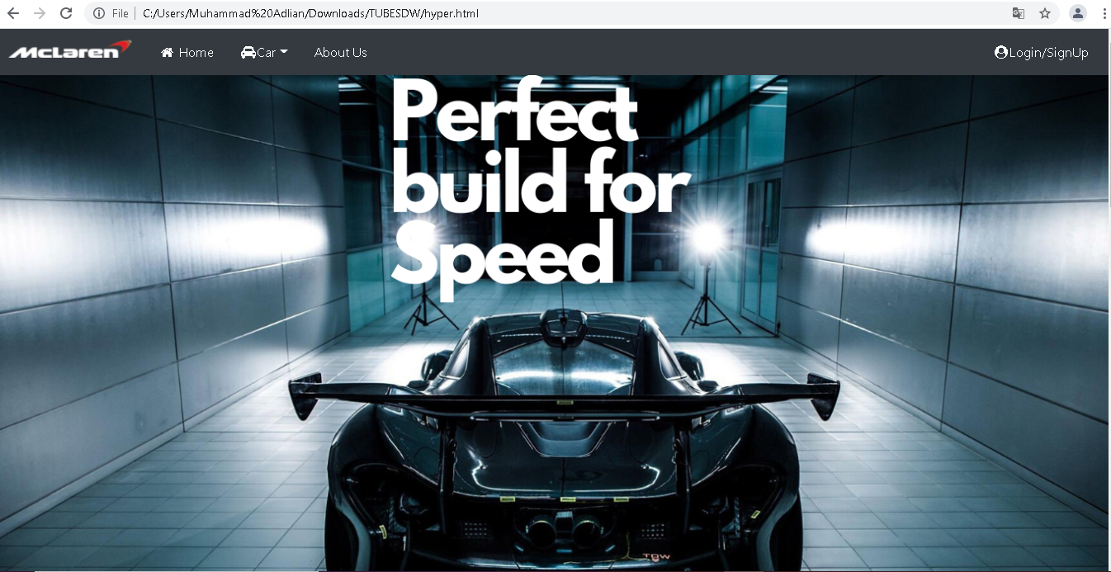

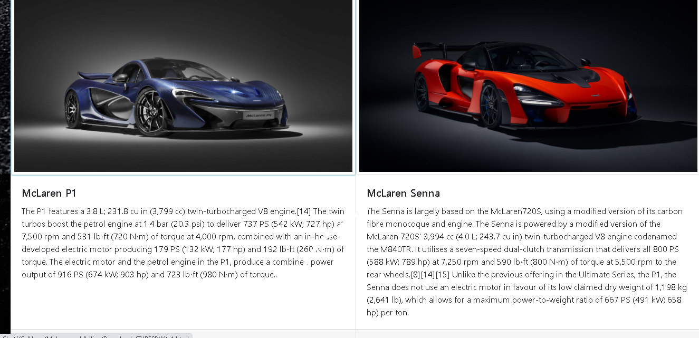

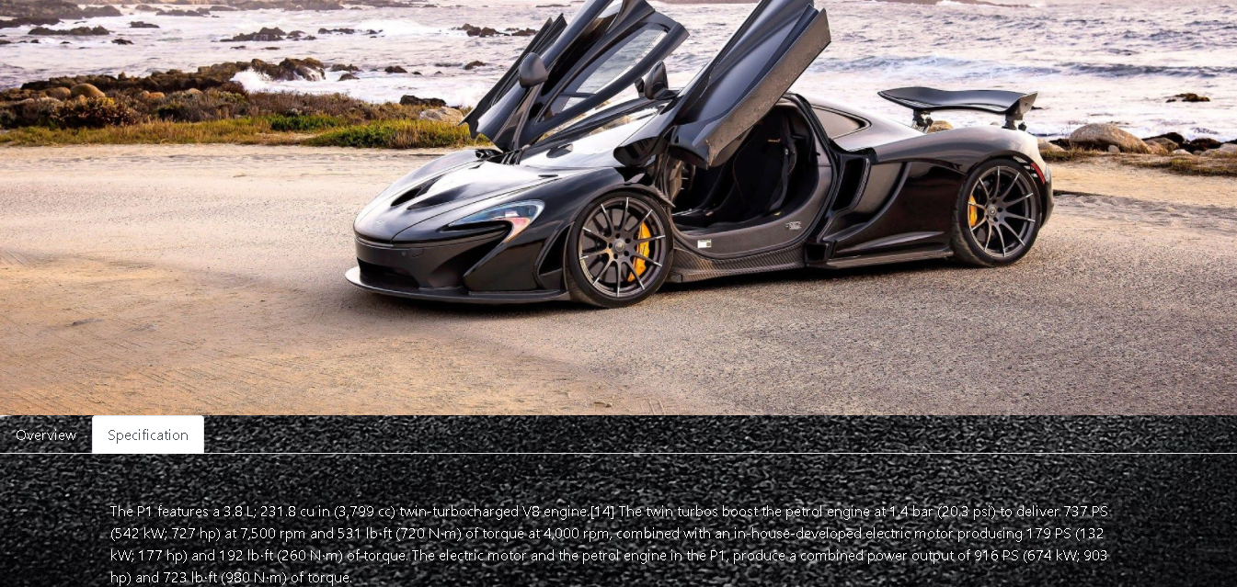

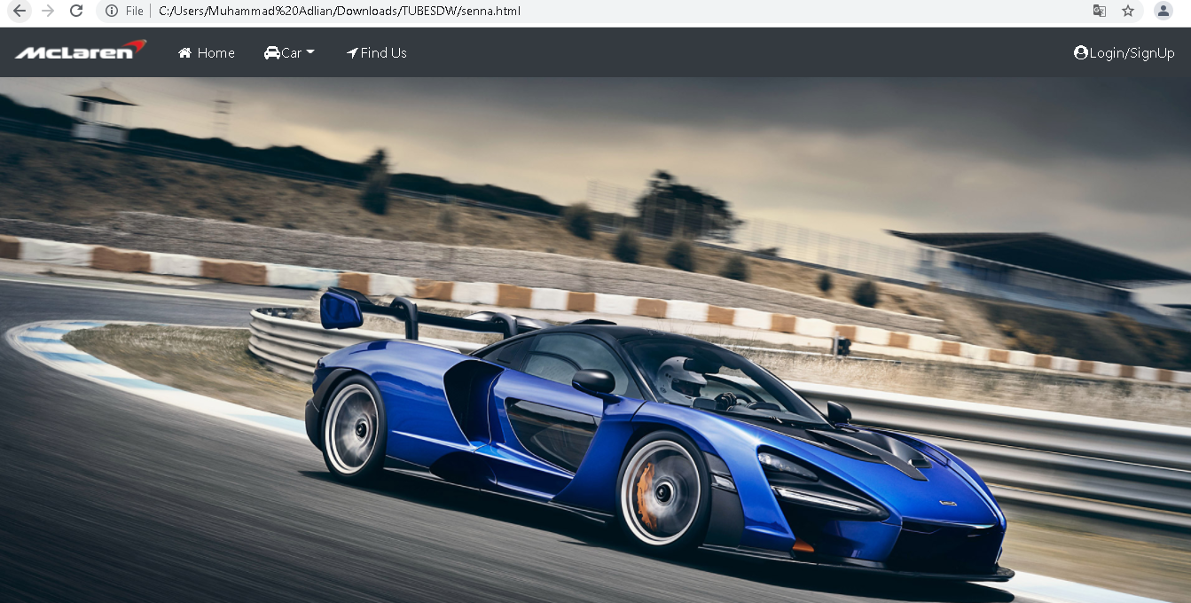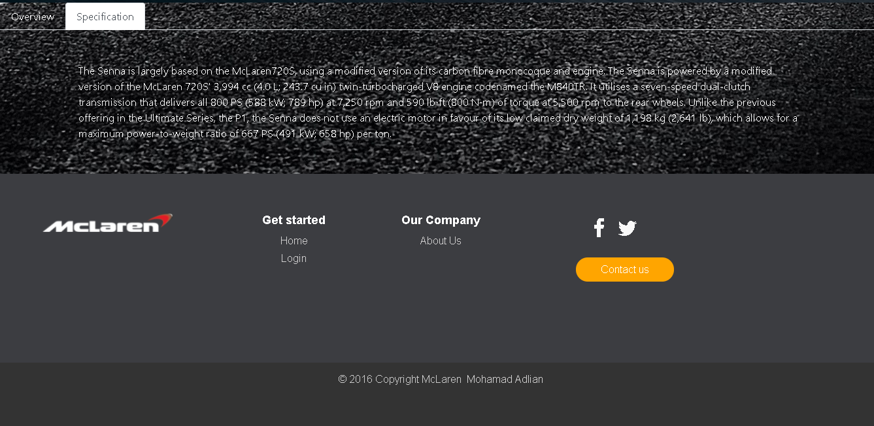

**Codingan hypercar**

<!DOCTYPE html>

<html lang=”en”>

<head>

<meta charset=”UTF-8”>

<meta name=”viewport” content=”width=device-width, initial-scale=1.0”>

<meta http-equiv=”X-UA-Compatible” content=”ie=edge”>

<title> Hypercar Menu</title>

<link rel=”stylesheet” href=”css/style.css”>

<link rel=”stylesheet” href=”css/bootstrap.css”>

<!—Icon🡪

<link rel=”stylesheet” href=”https://cdnjs.cloudflare.com/ajax/libs/font-awesome/4.7.0/css/font-awesome.min.css”>

<!—Memakai jQuery 🡪

<script src=”https://code.jquery.com/jquery-3.4.1.min.js”

integrity=”sha256-CSXorXvZcTkaix6Yvo6HppcZGetbYMGWSFlBw8HfCJo=”crossorigin=”anonymous”></script>

<!—Popper JS 🡪

<script src=”https://cdnjs.cloudflare.com/ajax/libs/popper.js/1.14.7/umd/popper.min.js”></script>

<!—Latest compiled JavaScript 🡪

<script src=”https://maxcdn.bootstrapcdn.com/bootstrap/4.3.1/js/bootstrap.min.js”></script>

<script src=”https://ajax.googleapis.com/ajax/libs/jquery/3.4.1/jquery.min.js”></script>

<script src=”https://maxcdn.bootstrapcdn.com/bootstrap/3.4.1/js/bootstrap.min.js”></script>

</head>

<body style=”background-image: url(images/race1.jpg);”>

<header>

<nav class=”navbar navbar-expand-md navbar-dark bg-dark “>

<a class=”navbar-brand” href=”home.html”>

<img src=”images/logo2.png” width=”150” class=”d-inline-block align-top” alt=””>

</a>

<button class=”navbar-toggler” type=”button” data-toggle=”collapse” data-target=”#navbarNav” aria-controls=”navbarNav” aria-expanded=”false” aria-label=”Toggle navigation”>

<span class=”navbar-toggler-icon”></span>

</button>

<div class=”collapse navbar-collapse “ id=”navbarNav”>

<ul class=”nav”>

<li class=”nav-item”>

<a class=”nav-link” href=”home.html”><i class=”fa fa-fw fa-home”></i> Home <span class=”sr-only”>(current)</span></a>

</li>

<li class=”nav-item dropdown”>

<a class=”nav-link dropdown-toggle” href=”#” id=”navbardrop” data-toggle=”dropdown” role=”button” aria-haspopup=”true” aria-expanded=”false” ><i class=”fa fa-fw fa-car”></i>Car</a>

<div class=”dropdown-menu”>

<a class=”dropdown-item” href=”hyper.html”> Hyper Car</a>

<a class=”dropdown-item” href=”sports.html”> Sports Car</a>

</div>

</li>

<li class=”nav-item”>

<a class=”nav-link” href=”about.html”fa fa-fw fa-location-arrow”></i>About Us</a>

</li>

</ul>

<div class=”navbar-nav ml-auto “>

<a href=”Login.html” class=”nav-item nav-link” style=”color:white;” ><i class=”fa fa-fw fa-user-circle”></i>Login/SignUp</a>

</div>

</ul>

</div>

</nav>

</div>

</header>

<div class=”img”>

<img src=”images/p1gtr.png” height=”100%” width=”100%” alt=””>

</div>

<article>

<div class=”card-group”>

<div class=”card”>

<a href=”p1.html”> <img src=”images/p12.jpg” class=”card-img-top “ alt=” McLaren p1” ></a>

<div class=”card-body”>

<h5 class=”card-title”>McLaren P1</h5>

<p class=”card-text”>The P1 features a 3.8 L; 231.8 cu in (3,799 cc) twin-turbocharged V8 engine.[14] The twin turbos boost the petrol engine at 1.4 bar (20.3 psi) to deliver 737 PS (542 kW; 727 hp) at 7,500 rpm and 531 lb⋅ft (720 N⋅m) of torque at 4,000 rpm, combined with an in-house-developed electric motor producing 179 PS (132 kW; 177 hp) and 192 lb⋅ft (260 N⋅m) of torque. The electric motor and the petrol engine in the P1, produce a combined power output of 916 PS (674 kW; 903 hp) and 723 lb⋅ft (980 N⋅m) of torque..</p>

</div>

<div class=”card-footer”>

<small class=”text-muted”>Price $229000</small>

</div>

</div>

<div class=”card”>

<a href=”senna.html”><img src=”images/senna1.jpg” class=”card-img-top “ alt=” McLaren Senna” ></a>

<div class=”card-body”>

<h5 class=”card-title”>McLaren Senna</h5>

<p class=”card-text”>The Senna is largely based on the McLaren720S, using a modified version of its carbon fibre monocoque and engine. The Senna is powered by a modified version of the McLaren 720S’ 3,994 cc (4.0 L; 243.7 cu in) twin-turbocharged V8 engine codenamed the M840TR. It utilises a seven-speed dual-clutch transmission that delivers all 800 PS (588 kW; 789 hp) at 7,250 rpm and 590 lb⋅ft (800 N⋅m) of torque at 5,500 rpm to the rear wheels.[8][14][15] Unlike the previous offering in the Ultimate Series, the P1, the Senna does not use an electric motor in favour of its low claimed dry weight of 1,198 kg (2,641 lb), which allows for a maximum power-to-weight ratio of 667 PS (491 kW; 658 hp) per ton.</p>

</div>

<div class=”card-footer”>

<small class=”text-muted”>Price $229000</small>

</div>

</div>

</div>

</article>

<!—Footer 🡪

<footer id=”myFooter”>

<div class=”container-fluid”>

<div class=”row text-center”>

<div class=”col-12 col-sm-6 col-md-3”>

<h1 class=”logo” style=”margin-top:30px;”></h1><img src=”images/logo2.png” width=”200px” >&nbsp;&nbsp;</img></h1>

</div>

<div class=”col-12 col-sm-6 col-md-2”>

<h5>Get started</h5>

<ul>

<li><a href=”home.html”>Home</a></li>

<li><a href=”Login.html”>Login</a></li>

</ul>

</div>

<div class=”col-12 col-sm-6 col-md-2”>

<h5>Our Company</h5>

<ul>

<li><a href=”about.html”>About Us</a></li>

</ul>

</div>

<div class=”col-md-3 social-networks”>

<div></div><a href=”#” class=”facebook”><i class=”fa fa-facebook”></i></a><a href=”#” class=”twitter”><i class=”fa fa-twitter”></i></a><a href=”#”></i></a>

<a href=”about.html”><button class=”btn btn-primary” type=”button” style=”margin-top:20px;”>Contact us</button></a>

</div>

</div>

<div class=”row footer-copyright”>

<div class=”col”>

<p>© 2016 Copyright McLaren &nbsp;<a href=”#”>Reza Septa Fabian</a></p>

</div>

</div>

</div>

</footer>

</body>

</body>

</html>

**Codingan p1**

<!DOCTYPE html>

<html lang=”en”>

<head>

<meta charset=”UTF-8”>

<meta name=”viewport” content=”width=device-width, initial-scale=1.0”>

<meta http-equiv=”X-UA-Compatible” content=”ie=edge”>

<title>McLaren P1</title>

<link rel=”stylesheet” href=”css/style.css”>

<link rel=”stylesheet” href=”css/bootstrap.css”>

<!—Icon🡪

<link rel=”stylesheet” href=”https://cdnjs.cloudflare.com/ajax/libs/font-awesome/4.7.0/css/font-awesome.min.css”>

<!—Memakai jQuery 🡪

<script src=”https://code.jquery.com/jquery-3.4.1.min.js”

integrity=”sha256-CSXorXvZcTkaix6Yvo6HppcZGetbYMGWSFlBw8HfCJo=”crossorigin=”anonymous”></script>

<!—Popper JS 🡪

<script src=”https://cdnjs.cloudflare.com/ajax/libs/popper.js/1.14.7/umd/popper.min.js”></script>

<!—Latest compiled JavaScript 🡪

<script src=”https://maxcdn.bootstrapcdn.com/bootstrap/4.3.1/js/bootstrap.min.js”></script>

<script src=”https://ajax.googleapis.com/ajax/libs/jquery/3.4.1/jquery.min.js”></script>

<script src=”https://maxcdn.bootstrapcdn.com/bootstrap/3.4.1/js/bootstrap.min.js”></script>

</head>

<body style=”background-image: url(images/race1.jpg);”>

<header>

<nav class=”navbar navbar-expand-md navbar-dark bg-dark “>

<a class=”navbar-brand” href=”home.html”>

<img src=”images/logo2.png” width=”150” class=”d-inline-block align-top” alt=””>

</a>

<button class=”navbar-toggler” type=”button” data-toggle=”collapse” data-target=”#navbarNav” aria-controls=”navbarNav” aria-expanded=”false” aria-label=”Toggle navigation”>

<span class=”navbar-toggler-icon”></span>

</button>

<div class=”collapse navbar-collapse “ id=”navbarNav”>

<ul class=”nav”>

<li class=”nav-item”>

<a class=”nav-link” href=”home.html”><i class=”fa fa-fw fa-home”></i> Home <span class=”sr-only”>(current)</span></a>

</li>

<li class=”nav-item dropdown”>

<a class=”nav-link dropdown-toggle” href=”#” id=”navbardrop” data-toggle=”dropdown” role=”button” aria-haspopup=”true” aria-expanded=”false”><i class=”fa fa-fw fa-car”></i>Car</a>

<div class=”dropdown-menu”>

<a class=”dropdown-item” href=”hyper.html”> Hyper Car</a>

<a class=”dropdown-item” href=”sports.html”> Sports Car</a>

</div>

</li>

<li class=”nav-item”>

<a class=”nav-link” href=”about.html”><i class=”fa fa-fw fa-location-arrow”></i>About Us</a>

</li>

</ul>

<div class=”navbar-nav ml-auto “>

<a href=”Login.html” class=”nav-item nav-link” style=”color:white;” ><i class=”fa fa-fw fa-user-circle”></i>Login/SignUp</a>

</div>

</ul>

</div>

</nav>

</div>

</header>

<div class=”img”>

<img src=”images/p13.jpg” height=”100%” width=”100%” alt=””>

</div>

<article>

<!—Nav tabs 🡪

<ul class=”nav nav-tabs”>

<li class=”nav-item”>

<a class=”nav-link active” data-toggle=”tab” href=”#Overview”>Overview</a>

</li>

<li class=”nav-item”>

<a class=”nav-link” data-toggle=”tab” href=”#Specification”>Specification</a>

</li>

</ul>

<!—Tab panes 🡪

<div class=”tab-content”>

<div class=”tab-pane container active” id=”Overview”>Designed, engineered and built to be the best driver’s car in the world.The McLaren F1 redefined the very concept of the supercar when it was launched in 1993.

Its spiritual successor, the P1™, would do the same 20 years later.The best-looking cars are the ones with real substance as well as style. The P1™ is a stunning piece of automotive design, but you won’t find any needless ornaments or frivolous styling features on it. Every surface has been designed to work, every part given the same aerodynamic consideration as if it was part of an aircraft or a Formula 1™ car.

</div>

<div class=”tab-pane container fade” id=”Specification”> The P1 features a 3.8 L; 231.8 cu in (3,799 cc) twin-turbocharged V8 engine.[14] The twin turbos boost the petrol engine at 1.4 bar (20.3 psi) to deliver 737 PS (542 kW; 727 hp) at 7,500 rpm and 531 lb⋅ft (720 N⋅m) of torque at 4,000 rpm, combined with an in-house-developed electric motor producing 179 PS (132 kW; 177 hp) and 192 lb⋅ft (260 N⋅m) of torque. The electric motor and the petrol engine in the P1, produce a combined power output of 916 PS (674 kW; 903 hp) and 723 lb⋅ft (980 N⋅m) of torque.

</div>

</div>

</article>

<!—Footer 🡪

<footer id=”myFooter”>

<div class=”container-fluid”>

<div class=”row text-center”>

<div class=”col-12 col-sm-6 col-md-3”>

<h1 class=”logo” style=”margin-top:30px;”></h1><img src=”images/logo2.png” width=”200px” >&nbsp;&nbsp;</img></h1>

</div>

<div class=”col-12 col-sm-6 col-md-2”>

<h5>Get started</h5>

<ul>

<li><a href=”home.html”>Home</a></li>

<li><a href=”Login.html”>Login</a></li>

</ul>

</div>

<div class=”col-12 col-sm-6 col-md-2”>

<h5>Our Company</h5>

<ul>

<li><a href=”about.html”>About Us</a></li>

</ul>

</div>

<div class=”col-md-3 social-networks”>

<div></div><a href=”#” class=”facebook”><i class=”fa fa-facebook”></i></a><a href=”#” class=”twitter”><i class=”fa fa-twitter”></i></a><a href=”#”></i></a>

<a href=”about.html”><button class=”btn btn-primary” type=”button” style=”margin-top:20px;”>Contact us</button></a>

</div>

</div>

<div class=”row footer-copyright”>

<div class=”col”>

<p>© 2016 Copyright McLaren &nbsp;<a href=”#”>Reza Septa Fabian</a></p>

</div>

</div>

</div>

</footer>

</body>

</body>

</html>

**Codingan Senna**

<!DOCTYPE html>

<html lang=”en”>

<head>

<meta charset=”UTF-8”>

<meta name=”viewport” content=”width=device-width, initial-scale=1.0”>

<meta http-equiv=”X-UA-Compatible” content=”ie=edge”>

<title>McLaren Senna</title>

<link rel=”stylesheet” href=”css/style.css”>

<link rel=”stylesheet” href=”css/bootstrap.css”>

<!—Icon🡪

<link rel=”stylesheet” href=”https://cdnjs.cloudflare.com/ajax/libs/font-awesome/4.7.0/css/font-awesome.min.css”>

<!—Memakai jQuery 🡪

<script src=”https://code.jquery.com/jquery-3.4.1.min.js”

integrity=”sha256-CSXorXvZcTkaix6Yvo6HppcZGetbYMGWSFlBw8HfCJo=”crossorigin=”anonymous”></script>

<!—Popper JS 🡪

<script src=”https://cdnjs.cloudflare.com/ajax/libs/popper.js/1.14.7/umd/popper.min.js”></script>

<!—Latest compiled JavaScript 🡪

<script src=”https://maxcdn.bootstrapcdn.com/bootstrap/4.3.1/js/bootstrap.min.js”></script>

<script src=”https://ajax.googleapis.com/ajax/libs/jquery/3.4.1/jquery.min.js”></script>

<script src=”https://maxcdn.bootstrapcdn.com/bootstrap/3.4.1/js/bootstrap.min.js”></script>

</head>

<body style=”background-image: url(images/race1.jpg);”>

<header>

<nav class=”navbar navbar-expand-md navbar-dark bg-dark “>

<a class=”navbar-brand” href=”home.html”>

<img src=”images/logo2.png” width=”150” class=”d-inline-block align-top” alt=””>

</a>

<button class=”navbar-toggler” type=”button” data-toggle=”collapse” data-target=”#navbarNav” aria-controls=”navbarNav” aria-expanded=”false” aria-label=”Toggle navigation”>

<span class=”navbar-toggler-icon”></span>

</button>

<div class=”collapse navbar-collapse “ id=”navbarNav”>

<ul class=”nav”>

<li class=”nav-item”>

<a class=”nav-link” href=”home.html”><i class=”fa fa-fw fa-home”></i> Home <span class=”sr-only”>(current)</span></a>

</li>

<li class=”nav-item dropdown”>

<a class=”nav-link dropdown-toggle” href=”#” id=”navbardrop” data-toggle=”dropdown” role=”button” aria-haspopup=”true” aria-expanded=”false”><i class=”fa fa-fw fa-car”></i>Car</a>

<div class=”dropdown-menu”>

<a class=”dropdown-item” href=”hyper.html”> Hyper Car</a>

<a class=”dropdown-item” href=”sports.html”> Sports Car</a>

</div>

</li>

<li class=”nav-item”>

<a class=”nav-link” href=”about.html”><i class=”fa fa-fw fa-location-arrow”></i>Find Us</a>

</li>

</ul>

<div class=”navbar-nav ml-auto “>

<a href=”Login.html” class=”nav-item nav-link” style=”color:white;” ><i class=”fa fa-fw fa-user-circle”></i>Login/SignUp</a>

</div>

</ul>

</div>

</nav>

</div>

</header>

<div class=”img”>

<img src=”images/senna4.jpg” height=”100%” width=”100%” alt=””>

</div>

<article>

<!—Nav tabs 🡪

<ul class=”nav nav-tabs”>

<li class=”nav-item”>

<a class=”nav-link active” data-toggle=”tab” href=”#Overview”>Overview</a>

</li>

<li class=”nav-item”>

<a class=”nav-link” data-toggle=”tab” href=”#Specification”>Specification</a>

</li>

</ul>

<!—Tab panes 🡪

<div class=”tab-content”>

<div class=”tab-pane container active” id=”Overview”>It is the most track-focused road car we have ever built, and it will set the fastest lap times of any McLaren to date. That is what has driven us to build a track car that is unashamedly without compromise. One that is legalised for road use, but not sanitised to suit it. Nothing else matters but to deliver the most intense driving experience around a circuit. Inspired by one of McLaren’s greatest racing drivers, the McLaren Senna is utterly dedicated to allowing the driver to be the best they can possibly be.The McLaren Senna is the fastest McLaren road car ever around a racetrack, but these abilities go hand-in-hand with an intensely involving and immersive experience that puts the driver utterly in control.

</div>

<div class=”tab-pane container fade” id=”Specification”> The Senna is largely based on the McLaren720S, using a modified version of its carbon fibre monocoque and engine. The Senna is powered by a modified version of the McLaren 720S’ 3,994 cc (4.0 L; 243.7 cu in) twin-turbocharged V8 engine codenamed the M840TR. It utilises a seven-speed dual-clutch transmission that delivers all 800 PS (588 kW; 789 hp) at 7,250 rpm and 590 lb⋅ft (800 N⋅m) of torque at 5,500 rpm to the rear wheels. Unlike the previous offering in the Ultimate Series, the P1, the Senna does not use an electric motor in favour of its low claimed dry weight of 1,198 kg (2,641 lb), which allows for a maximum power-to-weight ratio of 667 PS (491 kW; 658 hp) per ton.

</div>

</div>

</article>

<!—Footer 🡪

<footer id=”myFooter”>

<div class=”container-fluid”>

<div class=”row text-center”>

<div class=”col-12 col-sm-6 col-md-3”>

<h1 class=”logo” style=”margin-top:30px;”></h1><img src=”images/logo2.png” width=”200px” >&nbsp;&nbsp;</img></h1>

</div>

<div class=”col-12 col-sm-6 col-md-2”>

<h5>Get started</h5>

<ul>

<li><a href=”home.html”>Home</a></li>

<li><a href=”Login.html”>Login</a></li>

</ul>

</div>

<div class=”col-12 col-sm-6 col-md-2”>

<h5>Our Company</h5>

<ul>

<li><a href=”about.html”>About Us</a></li>

</ul>

</div>

<div class=”col-md-3 social-networks”>

<div></div><a href=”#” class=”facebook”><i class=”fa fa-facebook”></i></a><a href=”#” class=”twitter”><i class=”fa fa-twitter”></i></a><a href=”#”></i></a>

<a href=”about.html”><button class=”btn btn-primary” type=”button” style=”margin-top:20px;”>Contact us</button></a>

</div>

</div>

<div class=”row footer-copyright”>

<div class=”col”>

<p>© 2016 Copyright McLaren &nbsp;<a href=”#”>Reza Septa Fabian</a></p>

</div>

</div>

</div>

</footer>

</body>

</body>

</html>

**II.4 Menu About us**

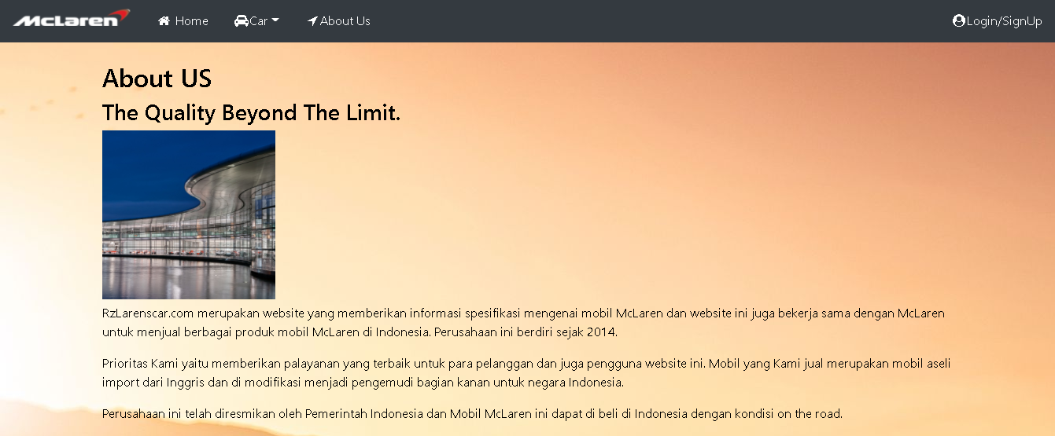

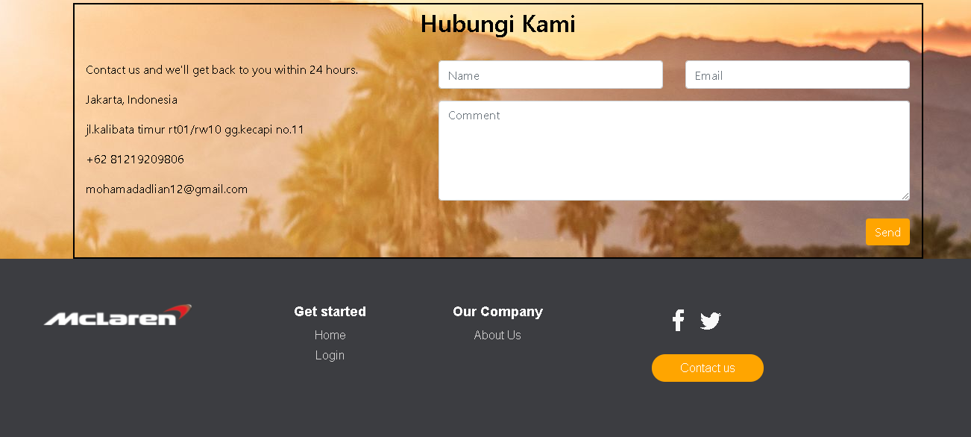

**Codingan About us**

<!DOCTYPE html>

<html lang=”en”>

<head>

<meta charset=”UTF-8”>

<meta name=”viewport” content=”width=device-width, initial-scale=1.0”>

<meta http-equiv=”X-UA-Compatible” content=”ie=edge”>

<title> About US</title>

<link rel=”stylesheet” href=”css/style.css”>

<link rel=”stylesheet” href=”css/bootstrap.css”>

<!—Icon🡪

<link rel=”stylesheet” href=”https://cdnjs.cloudflare.com/ajax/libs/font-awesome/4.7.0/css/font-awesome.min.css”>

<!—Memakai jQuery 🡪

<script src=”https://code.jquery.com/jquery-3.4.1.min.js”

integrity=”sha256-CSXorXvZcTkaix6Yvo6HppcZGetbYMGWSFlBw8HfCJo=”crossorigin=”anonymous”></script>

<!—Popper JS 🡪

<script src=”https://cdnjs.cloudflare.com/ajax/libs/popper.js/1.14.7/umd/popper.min.js”></script>

<!—Latest compiled JavaScript 🡪

<script src=”https://maxcdn.bootstrapcdn.com/bootstrap/4.3.1/js/bootstrap.min.js”></script>

<script src=”https://ajax.googleapis.com/ajax/libs/jquery/3.4.1/jquery.min.js”></script>

<script src=”https://maxcdn.bootstrapcdn.com/bootstrap/3.4.1/js/bootstrap.min.js”></script>

</head>

<body style=”background-image: url(images/senna.jpg);”>

<header>

<nav class=”navbar navbar-expand-md navbar-dark bg-dark “>

<a class=”navbar-brand” href=”home.html”>

<img src=”images/logo2.png” width=”150” class=”d-inline-block align-top” alt=””>

</a>

<button class=”navbar-toggler” type=”button” data-toggle=”collapse” data-target=”#navbarNav” aria-controls=”navbarNav” aria-expanded=”false” aria-label=”Toggle navigation”>

<span class=”navbar-toggler-icon”></span>

</button>

<div class=”collapse navbar-collapse “ id=”navbarNav”>

<ul class=”nav”>

<li class=”nav-item”>

<a class=”nav-link” href=”home.html”><i class=”fa fa-fw fa-home”></i> Home <span class=”sr-only”>(current)</span></a>

</li>

<li class=”nav-item dropdown”>

<a class=”nav-link dropdown-toggle” href=”#” id=”navbardrop” data-toggle=”dropdown” role=”button” aria-haspopup=”true” aria-expanded=”false” ><i class=”fa fa-fw fa-car”></i>Car</a>

<div class=”dropdown-menu”>

<a class=”dropdown-item” href=”hyper.html”> Hyper Car</a>

<a class=”dropdown-item” href=”#”> Sports Car</a>

</div>

</li>

<li class=”nav-item”>

<a class=”nav-link” href=”about.html”><i class=”fa fa-fw fa-location-arrow”></i>About Us</a>

</li>

</ul>

<div class=”navbar-nav ml-auto “>

<a href=”Login.html” class=”nav-item nav-link” style=”color:white;” ><i class=”fa fa-fw fa-user-circle”></i>Login/SignUp</a>

</div>

</ul>

</div>

</nav>

</div>

</header>

<article>

<div class=”container” id=”isi” >

<h2> About US </h2>

<h3> The Quality Beyond The Limit. </h3>

<img src=”images/company.jpg” alt=”company” id=”company”>

<p> RzLarenscar.com merupakan website yang memberikan informasi spesifikasi mengenai mobil McLaren dan website ini juga bekerja sama dengan McLaren untuk menjual berbagai produk mobil McLaren di Indonesia. Perusahaan ini berdiri sejak 2014. </p>

<p> </p>

<p> Prioritas Kami yaitu memberikan palayanan yang terbaik untuk para pelanggan dan juga pengguna website ini. Mobil yang Kami jual merupakan mobil aseli import dari Inggris dan di modifikasi menjadi pengemudi bagian kanan untuk negara Indonesia. </p>

<p></p>

<p> Perusahaan ini telah diresmikan oleh Pemerintah Indonesia dan Mobil McLaren ini dapat di beli di Indonesia dengan kondisi on the road. </p>

</div>

<div id=”contact” style=”background-color: ;” class=”container”>

<h2 class=”text-center”>Hubungi Kami</h2>

<br>

<div class=”row”>

<div class=”col-sm-5”>

<p>Contact us and we’ll get back to you within 24 hours.</p>

<p><span class=”glyphicon glyphicon-map-marker”></span> Bekasi, Indonesia</p>

<p><span class=”glyphicon glyphicon-map-marker”></span> Jalan Rusa VII No 75 Cikarang Baru</p>

<p><span class=”glyphicon glyphicon-phone”></span> +62 87777769016</p>

<p><span class=”glyphicon glyphicon-envelope”></span> rezaseptafabian@gmail.com </p>

</div>

<div class=”col-sm-7 slideanim”>

<div class=”row”>

<div class=”col-sm-6 form-group”>

<input class=”form-control” id=”name” name=”name” placeholder=”Name” type=”text” required>

</div>

<div class=”col-sm-6 form-group”>

<input class=”form-control” id=”email” name=”email” placeholder=”Email” type=”email” required>

</div>

</div>

<textarea class=”form-control” id=”comments” name=”comments” placeholder=”Comment” rows=”5”></textarea><br>

<div class=”row”>

<div class=”col-sm-12 form-group”>

<button class=”btn btn-default pull-right” type=”submit” id=”buttons” >Send</button>

</div>

</div>

</div>

</div>

</div>

</article>

<!—Footer 🡪

<footer id=”myFooter”>

<div class=”container-fluid”>

<div class=”row text-center”>

<div class=”col-12 col-sm-6 col-md-3”>

<h1 class=”logo” style=”margin-top:30px;”></h1><img src=”images/logo2.png” width=”200px” >&nbsp;&nbsp;</img></h1>

</div>

<div class=”col-12 col-sm-6 col-md-2”>

<h5>Get started</h5>

<ul>

<li><a href=”home.html”>Home</a></li>

<li><a href=”Login.html”>Login</a></li>

</ul>

</div>

<div class=”col-12 col-sm-6 col-md-2”>

<h5>Our Company</h5>

<ul>

<li><a href=”about.html”>About Us</a></li>

</ul>

</div>

<div class=”col-md-3 social-networks”>

<div></div><a href=”#” class=”facebook”><i class=”fa fa-facebook”></i></a><a href=”#” class=”twitter”><i class=”fa fa-twitter”></i></a><a href=”#”></i></a>

<a href=”about.html”><button class=”btn btn-primary” type=”button” style=”margin-top:20px;”>Contact us</button></a>

</div>

</div>

<div class=”row footer-copyright”>

<div class=”col”>

<p>© 2016 Copyright McLaren &nbsp;<a href=”#”>Reza Septa Fabian</a></p>

</div>

</div>

</div>

</footer>

</body>

</body>

</html>

**II.5 Menu Login**

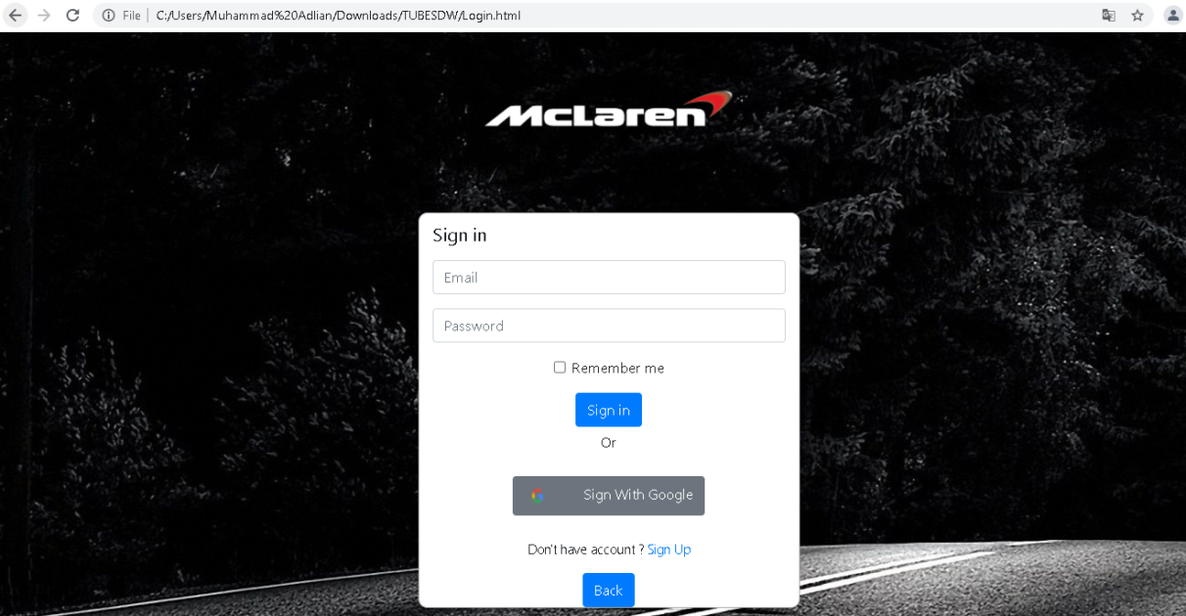

**Codingan menu login**

<!DOCTYPE html>

<html lang=”en”>

<head>

<meta charset=”UTF-8”>

<meta name=”viewport” content=”width=device-width, initial-scale=1.0”>

<meta http-equiv=”X-UA-Compatible” content=”ie=edge”>

<title> Login Menu</title>

<link rel=”stylesheet” href=”css/style.css”>

<link rel=”stylesheet” href=”css/bootstrap.css”>

<!—Icon🡪

<link rel=”stylesheet” href=”https://cdnjs.cloudflare.com/ajax/libs/font-awesome/4.7.0/css/font-awesome.min.css”>

<!—Memakai jQuery 🡪

<script src=”https://code.jquery.com/jquery-3.4.1.min.js”

integrity=”sha256-CSXorXvZcTkaix6Yvo6HppcZGetbYMGWSFlBw8HfCJo=”crossorigin=”anonymous”></script>

<!—Popper JS 🡪

<script src=”https://cdnjs.cloudflare.com/ajax/libs/popper.js/1.14.7/umd/popper.min.js”></script>

<!—Latest compiled JavaScript 🡪

<script src=”https://maxcdn.bootstrapcdn.com/bootstrap/4.3.1/js/bootstrap.min.js”></script>

<script src=”https://ajax.googleapis.com/ajax/libs/jquery/3.4.1/jquery.min.js”></script>

<script src=”https://maxcdn.bootstrapcdn.com/bootstrap/3.4.1/js/bootstrap.min.js”></script>

</head>

<body style=”background-image: url(images/race1.jpg); “>

<!—Jumbotron🡪

<div class=”jumbotron jumbotron-fluid” style=”text-align: center; background-color: transparent;”>

<div class=”container”>

<img src=”images/logo2.png” width=”25%” >

</div>

</div>

<!—form login🡪

<form>

<div class=”container” style=”text-align: center; background-color: white; width: 425px; border: 1px solid rgb(172, 171, 171); border-radius: 10px;”>

<h4 class=”lead” style=”text-align: left; margin-top: 10px;”><b> Sign in</b></h4>

<div class=”form-group row” >

<div class=”col” style=”margin-top:10px;”>

<input type=”email” class=”form-control” id=”inputEmail3” placeholder=”Email”>

</div>

</div>

<div class=”form-group row”>

<div class=”col” >

<input type=”password” class=”form-control” id=”inputPassword3” placeholder=”Password”>

</div>

</div>

<div class=”col”>

<div class=”form-check”>

<input class=”form-check-input” type=”checkbox” id=”autoSizingCheck2”>

<label class=”form-check-label” for=”autoSizingCheck2”>

<p> Remember me</p>

</label>

</div>

</div>

<div class=”form-group row” style=”margin-bottom: 5px;”>

<div class=”col”>

<button type=”submit” class=”btn btn-primary”>Sign in</button>

</div>

</div>

<p> Or</p>

<div class=”form-group row” style=”padding: 10px;”>

<div class=”col”>

<button type=”submit” class=”btn btn-secondary” ><img src=”images/google.png” height=”30px” width=”30px”>&emsp;&emsp; Sign With Google</button>

</div>

</div>

<p class=”lead” style=”font-size: 15px;”> Don’t have account ? <a href=”logup.html”> Sign Up</a></p>

<button class=”btn bg-primary”>

<a href=”home.html” style=”color:white;”> Back </a>

</button>

<br>

</div>

</form>

</body>

</html>

**II.6 Menu style.css**

html{

font-family: Lato,Helvetica,Arial,sans-serif;

scroll-behavior: smooth;

}

.nav-link{

color:white;”

}

.nav-item:hover{

color: #fff;

display: inline-block;

text-decoration: none;

overflow: hidden;

vertical-align: top;

background: white;

-webkit-perspective: 600px;

-moz-perspective: 600px;

-ms-perspective: 600px;

perspective: 600px;

-webkit-perspective-origin: 50% 50%;

-moz-perspective-origin: 50% 50%;

-ms-perspective-origin: 50% 50%;

perspective-origin: 50% 50%;

}

.card-column{

padding:20px;

}

#myFooter {

background-color: #3c3d41;

color: white;

padding-top: 30px;

font-family: Lato,Helvetica,Arial,sans-serif;

}

#myFooter .footer-copyright {

background-color: #333333;

padding-top: 3px;

padding-bottom: 100px;

text-align: center;

}

#myFooter .row {

margin-bottom: 60px;

}

#myFooter .footer-copyright p {

margin: 10px;

color: #ccc;

}

#myFooter ul {

list-style-type: none;

padding-left: 0;

line-height: 1.7;

}

#myFooter h5 {

font-size: 18px;

color: white;

font-weight: bold;

margin-top: 30px;

}

#myFooter a {

color: #d2d1d1;

text-decoration: none;

}

#myFooter a:hover, #myFooter a:focus {

text-decoration: none;

color: white;

}

#myFooter .social-networks {

text-align: center;

padding-top: 30px;

padding-bottom: 16px;

}

#myFooter .social-networks a {

font-size: 32px;

color: #f9f9f9;

padding: 10px;

transition: 0.2s;

}

#myFooter .social-networks a:hover {

text-decoration: none;

}

#myFooter .facebook:hover {

color: #0077e2;

}

#myFooter .twitter:hover {

color: #00aced;

}

#myFooter .btn {

color: white;

background-color: orange;

border-radius: 20px;

border: none;

width: 150px;

display: block;

margin: 0 auto;

margin-top: 10px;

line-height: 25px;

}

@media screen and (max-width: 767px) {

#myFooter {

text-align: center;

}

}

.card-group{

padding-top: 15px;

padding-bottom: 15px;

padding-left: 20px;

padding-right: 20px;

}

.card-img-top{

border: 1px solid #ddd; /* Gray border */

border-radius: 4px; /* Rounded border */

padding: 5px; /* Some padding */

width: 150px; /* Set a small width */

}

.card-img-top:hover {

box-shadow: 0 0 2px 1px rgba(0, 140, 186, 0.5);

}

.tab-pane{

padding-top:50px;

padding-bottom: 50px;

}

.tab-content{

color: white;

}

#isi{

padding: 25px;

color: black;

}

#company{

height: 220px;

width: 220px;

padding-bottom: 5px;

transition: 0.3s;

}

#company:hover{

opacity: 0.7;

}

#contact{

color: black;

border: 2px solid black;

padding-top: 5px;

}

#buttons{

border: 2px;

background-color: orange;

color: white;

}

**11.6 Menu Lowongan Kerja**

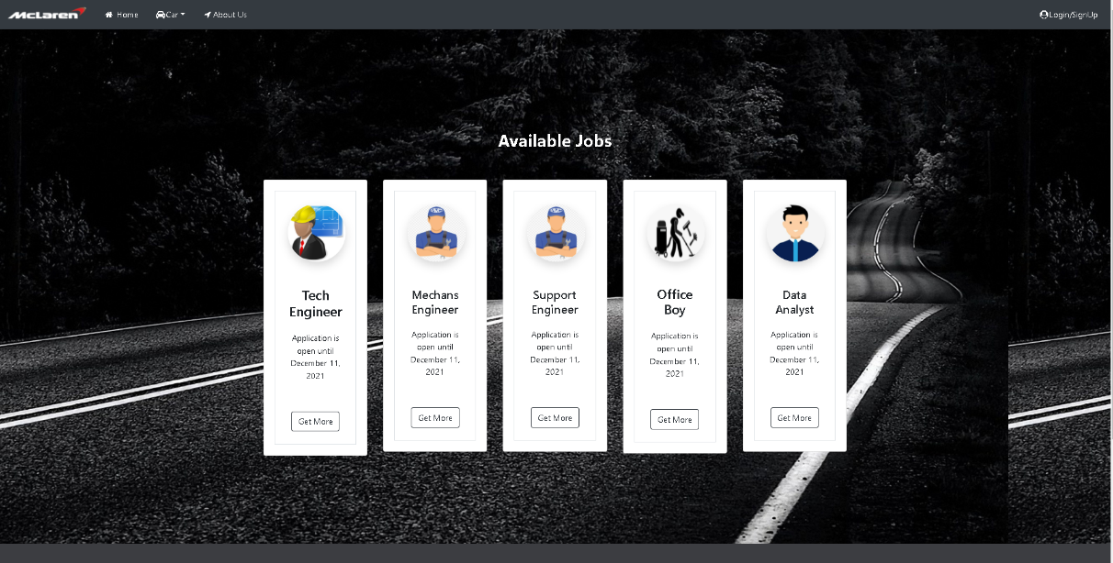

**Source Code**

<!DOCTYPE html>

<html lang="en">

<head >

    <meta charset="UTF-8">

    <meta name="viewport" content="width=device-width, initial-scale=1.0">

    <meta http-equiv="X-UA-Compatible" content="ie=edge">

    <title>Welcome To Mclaren</title>

    <link href="indexloker.css" rel="stylesheet">

    <link rel="stylesheet" href="css/style.css">

    <link rel="stylesheet" href="css/bootstrap.css">

*<!-- Icon-->*

    <link rel="stylesheet" href="https://cdnjs.cloudflare.com/ajax/libs/font-awesome/4.7.0/css/font-awesome.min.css">

*<!-- Memakai jQuery  -->*

    <script src="https://code.jquery.com/jquery-3.4.1.min.js"

    integrity="sha256-CSXorXvZcTkaix6Yvo6HppcZGetbYMGWSFlBw8HfCJo="crossorigin="anonymous"></script>

*<!-- Popper JS -->*

    <script src="https://cdnjs.cloudflare.com/ajax/libs/popper.js/1.14.7/umd/popper.min.js"></script>

*<!-- Latest compiled JavaScript -->*

      <script src="https://maxcdn.bootstrapcdn.com/bootstrap/4.3.1/js/bootstrap.min.js"></script>

    <script src="https://ajax.googleapis.com/ajax/libs/jquery/3.4.1/jquery.min.js"></script>

    <script src="https://maxcdn.bootstrapcdn.com/bootstrap/3.4.1/js/bootstrap.min.js"></script>

    <style>

      h2{

      text-align: center;

      color:white;

      }

    </style>

</head>

<body style="background-image: url(./images/race1.jpg);">

            <nav class="navbar navbar-expand-md navbar-dark bg-dark">

                <a class="navbar-brand" href="home.html">

                  <img src="images/logo2.png" width="150"  class="d-inline-block align-top" alt="">

                  </a>

                <button class="navbar-toggler" type="button" data-toggle="collapse" data-target="#navbarNav" aria-controls="navbarNav" aria-expanded="false" aria-label="Toggle navigation">

                <span class="navbar-toggler-icon"></span>

                </button>

                <div class="collapse navbar-collapse " id="navbarNav">

                  <ul class="nav">

                    <li class="nav-item">

                      <a class="nav-link" href="home.html"><i class="fa fa-fw fa-home"></i> Home <span class="sr-only">(current)</span></a>

                    </li>

                    <li class="nav-item dropdown">

                      <a class="nav-link dropdown-toggle" href="#" id="navbardrop" data-toggle="dropdown" role="button" aria-haspopup="true" aria-expanded="false"><i class="fa fa-fw fa-car"></i>Car</a>

                      <div class="dropdown-menu">

                          <a class="dropdown-item" href="hyper.html"> Hyper Car</a>

                          <a class="dropdown-item" href="sports.html"> Sports Car</a>

                      </div>

                    </li>

                    <li class="nav-item">

                      <a class="nav-link" href="about.html"><i class="fa fa-fw fa-location-arrow"></i>About Us</a>

                    </li>

                    </ul>

                    <div class="navbar-nav ml-auto ">

                        <a href="Login.html" class="nav-item nav-link" style="color:white;" ><i class="fa fa-fw fa-user-circle"></i>Login/SignUp</a>

                    </div>

                    </ul>

                </div>

            </nav>

        </div>

    </header>

*<!-- Loker content -->*

  <br>

  <br>

<br>

<br>

<br>

<br>

<br>

<br>

  <link rel="stylesheet" href="https://cdn.jsdelivr.net/npm/boxicons@2.0.7/css/boxicons.min.css">

<h2><b>Available Jobs</b> </h2>

<br><br>

<div class="container">

<div class="row row-cols-1 row-cols-lg-2 row-cols-xl-5">

    <div class="col">

        <div class="card radius-15">

            <div class="card-body text-center">

                <div class="p-4 border radius-15">

                    <img src="https://www.freeiconspng.com/uploads/project-icon-14.png" width="110" height="110" class="rounded-circle shadow" alt="">

                    <h5 class="mb-0 mt-5" style="text-align: center; font-size: 160%;">Tech Engineer</h5><br>

                     <p>Application is open until December 11, 2021</p>

                    <div class="list-inline contacts-social mt-3 mb-3"> <a href="javascript:;" class="list-inline-item bg-facebook text-white border-0"><i class="bx bxl-facebook"></i></a>

                        <a href="javascript:;" class="list-inline-item bg-twitter text-white border-0"><i class="bx bxl-twitter"></i></a>

                        <a href="javascript:;" class="list-inline-item bg-linkedin text-white border-0"><i class="bx bxl-linkedin"></i></a>

                    </div>

                    <div class="d-grid"> <a href="technical_engineer.html" class="btn btn-outline-dark radius-15">Get More</a>

                    </div>

                </div>

            </div>

        </div>

    </div>

    <div class="col">

        <div class="card radius-15">

            <div class="card-body text-center">

                <div class="p-4 border radius-15">

                    <img src="./images/mechanical-cartoon.png" width="110" height="110" class="rounded-circle shadow" alt="">

                    <h5 class="mb-0 mt-5" style="text-align: center; font-size: 142%;">Mechans Engineer</h5><br>

                    <p>Application is open until December 11, 2021</p>

                    <div class="list-inline contacts-social mt-3 mb-3"> <a href="javascript:;" class="list-inline-item bg-facebook text-white border-0"><i class="bx bxl-facebook"></i></a>

                        <a href="javascript:;" class="list-inline-item bg-twitter text-white border-0"><i class="bx bxl-twitter"></i></a>

                        <a href="javascript:;" class="list-inline-item bg-linkedin text-white border-0"><i class="bx bxl-linkedin"></i></a>

                    </div>

                    <div class="d-grid"> <a href="mechanical.html" class="btn btn-outline-dark radius-15">Get More</a>

                    </div>

                </div>

            </div>

        </div>

    </div>

    <div class="col">

        <div class="card radius-15">

            <div class="card-body text-center">

                <div class="p-4 border radius-15">

                    <img src="./images/mechanical-cartoon.png" width="110" height="110" class="rounded-circle shadow" alt="">

                    <h5 class="mb-0 mt-5" style="text-align: center; font-size: 142%;">Support Engineer</h5><br>

                    <p>Application is open until December 11, 2021</p>

                    <div class="list-inline contacts-social mt-3 mb-3"> <a href="javascript:;" class="list-inline-item bg-facebook text-white border-0"><i class="bx bxl-facebook"></i></a>

                        <a href="javascript:;" class="list-inline-item bg-twitter text-white border-0"><i class="bx bxl-twitter"></i></a>

                        <a href="javascript:;" class="list-inline-item bg-linkedin text-white border-0"><i class="bx bxl-linkedin"></i></a>

                    </div>

                    <div class="d-grid"> <a href="support_engineer.html" class="btn btn-outline-dark radius-15">Get More</a>

                    </div>

                </div>

            </div>

        </div>

    </div>

    <div class="col">

        <div class="card radius-15">

            <div class="card-body text-center">

                <div class="p-4 border radius-15">

                    <img src="./images/office-boy.png" width="110" height="110" class="rounded-circle shadow" alt="">

                    <h5 class="mb-0 mt-5" style="text-align: center; font-size: 150%;">Office Boy</h5><br>

                    <p>Application is open until December 11, 2021</p>

                    <div class="list-inline contacts-social mt-3 mb-3"> <a href="javascript:;" class="list-inline-item bg-facebook text-white border-0"><i class="bx bxl-facebook"></i></a>

                        <a href="javascript:;" class="list-inline-item bg-twitter text-white border-0"><i class="bx bxl-twitter"></i></a>

                        <a href="javascript:;" class="list-inline-item bg-linkedin text-white border-0"><i class="bx bxl-linkedin"></i></a>

                    </div>

                    <div class="d-grid"> <a href="Officeboy.html" class="btn btn-outline-dark radius-15">Get More</a>

                    </div>

                </div>

            </div>

        </div>

    </div>

  <div class="col-sm">

    <div class="card radius-15">

        <div class="card-body text-center">

            <div class="p-4 border radius-15">

                <img src="./images/data-analyst.jpg" width="110" height="110" class="rounded-circle shadow" alt="">

                <h5 class="mb-0 mt-5" style="text-align: center; font-size: 142%;">Data Analyst</h5><br>

                <p>Application is open until December 11, 2021</p>

                <div class="list-inline contacts-social mt-3 mb-3"> <a href="javascript:;" class="list-inline-item bg-facebook text-white border-0"><i class="bx bxl-facebook"></i></a>

                    <a href="javascript:;" class="list-inline-item bg-twitter text-white border-0"><i class="bx bxl-twitter"></i></a>

                    <a href="javascript:;" class="list-inline-item bg-linkedin text-white border-0"><i class="bx bxl-linkedin"></i></a>

                </div>

                <div class="d-grid"> <a href="data_analyst.html" class="btn btn-outline-dark radius-15">Get More</a>

                </div>

            </div>

        </div>

    </div>

</div>

</div>

</div>

</div>

</div>

<br>

<br>

<br>

<br>

<br>

<br>

<br>

*<!-- akhir content -->*

*<!-- Footer -->*

        <footer id="myFooter">

            <div class="container-fluid">

                <div class="row text-center">

                    <div class="col-12 col-sm-6 col-md-3">

                        <h1 class="logo" style="margin-top:30px;"></h1><img src="images/logo2.png" width="200px" >&nbsp;&nbsp;</img></h1>

                    </div>

                    <div class="col-12 col-sm-6 col-md-2">

                        <h5>Get started</h5>

                        <ul>

                            <li><a href="home.html">Home</a></li>

                            <li><a href="Login.html">Login</a></li>

                        </ul>

                    </div>

                    <div class="col-12 col-sm-6 col-md-2">

                        <h5>Our Company</h5>

                        <ul>

                            <li><a href="about.html">About Us</a></li>

                            <li><a href="indexloker.html">Carrer</a></li>

                        </ul>

                    </div>

                    <div class="col-md-3 social-networks">

                        <div></div><a href="#" class="facebook"><i class="fa fa-facebook"></i></a><a href="#" class="twitter"><i class="fa fa-twitter"></i></a><a href="#"></i></a>

                        <a href="about.html"><button  class="btn btn-primary" type="button" style="margin-top:20px;">Contact us</button></a>

                    </div>

                </div>

                <div class="copyright bg-dark">

                        <p><center>© 2016 Copyright McLaren &nbsp;<a href="#">Mohamad Adlian</a></center></p>

                </div>

            </div>

        </footer>

</body>

</html>

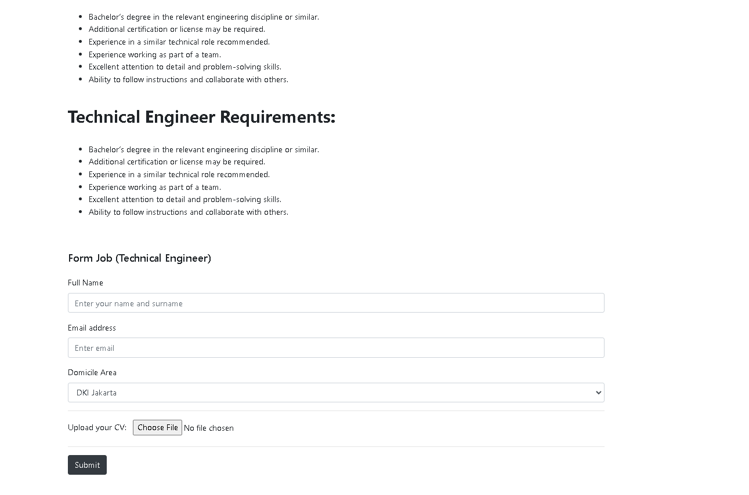**Bagian 1 (Form Job Techinal Engineer)**

**BAB III**

**Source Code**

<!DOCTYPE html>

<html lang="en">

<head >

    <meta charset="UTF-8">

    <meta name="viewport" content="width=device-width, initial-scale=1.0">

    <meta http-equiv="X-UA-Compatible" content="ie=edge">

    <title>Form Job 1</title>

  <link rel="stylesheet" href="css/style.css">

  <link rel="stylesheet" href="css/bootstrap.css">

*<!-- Icon-->*

  <link rel="stylesheet" href="https://cdnjs.cloudflare.com/ajax/libs/font-awesome/4.7.0/css/font-awesome.min.css">

*<!-- Memakai jQuery  -->*

  <script src="https://code.jquery.com/jquery-3.4.1.min.js"

    integrity="sha256-CSXorXvZcTkaix6Yvo6HppcZGetbYMGWSFlBw8HfCJo="crossorigin="anonymous"></script>

*<!-- Popper JS -->*

    <script src="https://cdnjs.cloudflare.com/ajax/libs/popper.js/1.14.7/umd/popper.min.js"></script>

*<!-- Latest compiled JavaScript -->*

    <script src="https://maxcdn.bootstrapcdn.com/bootstrap/4.3.1/js/bootstrap.min.js"></script>

    <script src="https://ajax.googleapis.com/ajax/libs/jquery/3.4.1/jquery.min.js"></script>

    <script src="https://maxcdn.bootstrapcdn.com/bootstrap/3.4.1/js/bootstrap.min.js"></script>

</head>

<style>

    h1 {

  font-size: 20px;

  margin-top: 24px;

  margin-bottom: 24px;

}

img {

height: 40px;

}

</style>

<body>

<nav class="navbar navbar-expand-md navbar-dark bg-dark">

        <a class="navbar-brand" href="home.html">

          <img src="images/logo2.png" width="150"  class="d-inline-block align-top" alt="">

          </a>

        <button class="navbar-toggler" type="button" data-toggle="collapse" data-target="#navbarNav" aria-controls="navbarNav" aria-expanded="false" aria-label="Toggle navigation">

        <span class="navbar-toggler-icon"></span>

        </button>

        <div class="collapse navbar-collapse " id="navbarNav">

          <ul class="nav">

          <li class="nav-item">

            <a class="nav-link" href="home.html"><i class="fa fa-fw fa-home"></i> Home <span class="sr-only">(current)</span></a>

          </li>

          <li class="nav-item dropdown">

            <a class="nav-link dropdown-toggle" href="#" id="navbardrop" data-toggle="dropdown" role="button" aria-haspopup="true" aria-expanded="false"><i class="fa fa-fw fa-car"></i>Car</a>

            <div class="dropdown-menu">

              <a class="dropdown-item" href="hyper.html"> Hyper Car</a>

              <a class="dropdown-item" href="sports.html"> Sports Car</a>

            </div>

          </li>

          <li class="nav-item">

            <a class="nav-link" href="about.html"><i class="fa fa-fw fa-location-arrow"></i>About Us</a>

          </li>

          </ul>

          <div class="navbar-nav ml-auto ">

            <a href="Login.html" class="nav-item nav-link" style="color:white;" ><i class="fa fa-fw fa-user-circle"></i>Login/SignUp</a>

          </div>

          </ul>

        </div>

      </nav>

    </div>

  </header>

*<!-- content -->*

   <div class="col-md-6 offset-md-3 mt-5">

     <h2><b>Technical Engineer Job Description</b></h2>

       <br>

      <p>We are searching for an innovative, deadline-driven technical engineer to join our company. The technical engineer’s responsibilities include assisting Engineers with various tasks like design, construction, equipment installation, system configuration, maintenance, developing preventative maintenance plans, and providing customer support. You should also be able to troubleshoot systems, identify problems, and write up reports.

      To be successful as a technical engineer, you should be meticulous, efficient, and have sound knowledge of the relevant engineering discipline. Outstanding candidates are team players with exemplary problem-solving abilities.</p>

      <br>

      <br>

      <b>Technical Engineer Responsibilities:</b>

      <br><br>

      <ul>

        <li>Bachelor’s degree in the relevant engineering discipline or similar.</li>

        <li>Additional certification or license may be required.</li>

        <li>Experience in a similar technical role recommended.</li>

        <li>Experience working as part of a team.</li>

        <li>Excellent attention to detail and problem-solving skills.</li>

        <li>Ability to follow instructions and collaborate with others.</li>

        </ul>

     <br>

     <h2><b>Technical Engineer Requirements:</b></h2>

     <br>

     <ul>

     <li>Bachelor’s degree in the relevant engineering discipline or similar.</li>

     <li>Additional certification or license may be required.</li>

     <li>Experience in a similar technical role recommended.</li>

     <li>Experience working as part of a team.</li>

     <li>Excellent attention to detail and problem-solving skills.</li>

     <li>Ability to follow instructions and collaborate with others.</li>

     </ul>

     <br>

     <h1>Form Job (Technical Engineer)</h1>

     <form accept-charset="UTF-8" action="https://getform.io/f/{your-form-endpoint-goes-here}" method="POST"  target="_blank">

       <div class="form-group">

         <label for="exampleInputName">Full Name</label>

         <input type="text" name="fullname" class="form-control" id="exampleInputName" placeholder="Enter your name and surname" required="required">

       </div>

       <div class="form-group">

         <label for="exampleInputEmail1" required="required">Email address</label>

         <input type="email" name="email" class="form-control" id="exampleInputEmail1" aria-describedby="emailHelp" placeholder="Enter email">

       </div>

       <div class="form-group">

         <label for="exampleFormControlSelect1">Domicile Area</label>

         <select class="form-control" id="exampleFormControlSelect1" name="platform" required="required">

           <option>DKI Jakarta</option>

           <option>Jawa Barat</option>

           <option>Jawa Timur</option>

         </select>

       </div>

       <hr>

       <div class="form-group mt-3">

         <label class="mr-2">Upload your CV:</label>

         <input type="file" name="file">

       </div>

       <hr>

       <button type="submit" class="btn btn-dark">Submit</button>

     </form>

 </div>

 <br>

 <br>

*<!-- akhir content -->*

*<!-- Footer -->*

<footer id="myFooter">

    <div class="container-fluid">

        <div class="row text-center">

            <div class="col-12 col-sm-6 col-md-3">

                <h1 class="logo" style="margin-top:30px;"></h1><img src="images/logo2.png" width="200px" >&nbsp;&nbsp;</img></h1>

            </div>

            <div class="col-12 col-sm-6 col-md-2">

                <h5>Get started</h5>

                <ul>

                    <li><a href="home.html">Home</a></li>

                    <li><a href="Login.html">Login</a></li>

                </ul>

            </div>

            <div class="col-12 col-sm-6 col-md-2">

                <h5>Our Company</h5>

                <ul>

                    <li><a href="about.html">About Us</a></li>

                </ul>

            </div>

            <div class="col-md-3 social-networks">

                <div></div><a href="#" class="facebook"><i class="fa fa-facebook"></i></a><a href="#" class="twitter"><i class="fa fa-twitter"></i></a><a href="#"></i></a>

                <a href="about.html"><button  class="btn btn-primary" type="button" style="margin-top:20px;">Contact us</button></a>

            </div>

        </div>

        <div class="copyright bg-dark">

                <p><center>© 2016 Copyright McLaren &nbsp;<a href="#">Mohamad Adlian</a></center></p>

        </div>

    </div>

</footer>

</body>

</html>

**Bagian 2 (Form Job Mechanical Engineer)**

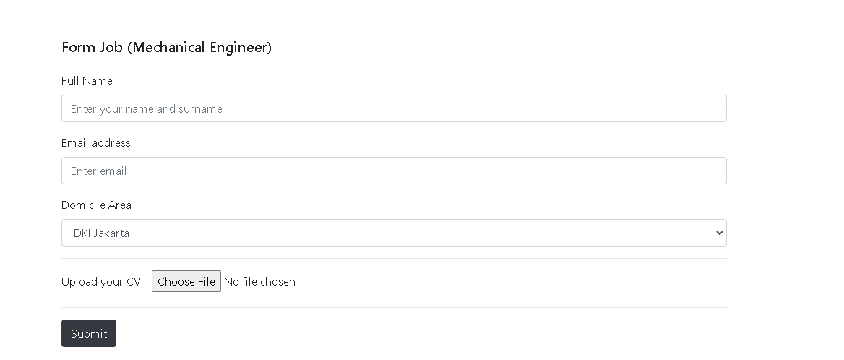

**Source Code**

<!DOCTYPE html>

<html lang="en">

<head >

    <meta charset="UTF-8">

    <meta name="viewport" content="width=device-width, initial-scale=1.0">

    <meta http-equiv="X-UA-Compatible" content="ie=edge">

    <title>Form Job 2</title>

  <link rel="stylesheet" href="css/style.css">

  <link rel="stylesheet" href="css/bootstrap.css">

*<!-- Icon-->*

  <link rel="stylesheet" href="https://cdnjs.cloudflare.com/ajax/libs/font-awesome/4.7.0/css/font-awesome.min.css">

*<!-- Memakai jQuery  -->*

  <script src="https://code.jquery.com/jquery-3.4.1.min.js"

    integrity="sha256-CSXorXvZcTkaix6Yvo6HppcZGetbYMGWSFlBw8HfCJo="crossorigin="anonymous"></script>

*<!-- Popper JS -->*

    <script src="https://cdnjs.cloudflare.com/ajax/libs/popper.js/1.14.7/umd/popper.min.js"></script>

*<!-- Latest compiled JavaScript -->*

    <script src="https://maxcdn.bootstrapcdn.com/bootstrap/4.3.1/js/bootstrap.min.js"></script>

    <script src="https://ajax.googleapis.com/ajax/libs/jquery/3.4.1/jquery.min.js"></script>

    <script src="https://maxcdn.bootstrapcdn.com/bootstrap/3.4.1/js/bootstrap.min.js"></script>

</head>

<style>

    h1 {

  font-size: 20px;

  margin-top: 24px;

  margin-bottom: 24px;

}

img {

height: 40px;

}

</style>

<body>

<nav class="navbar navbar-expand-md navbar-dark bg-dark">

        <a class="navbar-brand" href="home.html">

          <img src="images/logo2.png" width="150"  class="d-inline-block align-top" alt="">

          </a>

        <button class="navbar-toggler" type="button" data-toggle="collapse" data-target="#navbarNav" aria-controls="navbarNav" aria-expanded="false" aria-label="Toggle navigation">

        <span class="navbar-toggler-icon"></span>

        </button>

        <div class="collapse navbar-collapse " id="navbarNav">

          <ul class="nav">

          <li class="nav-item">

            <a class="nav-link" href="home.html"><i class="fa fa-fw fa-home"></i> Home <span class="sr-only">(current)</span></a>

          </li>

          <li class="nav-item dropdown">

            <a class="nav-link dropdown-toggle" href="#" id="navbardrop" data-toggle="dropdown" role="button" aria-haspopup="true" aria-expanded="false"><i class="fa fa-fw fa-car"></i>Car</a>

            <div class="dropdown-menu">

              <a class="dropdown-item" href="hyper.html"> Hyper Car</a>

              <a class="dropdown-item" href="sports.html"> Sports Car</a>

            </div>

          </li>

          <li class="nav-item">

            <a class="nav-link" href="about.html"><i class="fa fa-fw fa-location-arrow"></i>About Us</a>

          </li>

          </ul>

          <div class="navbar-nav ml-auto ">

            <a href="Login.html" class="nav-item nav-link" style="color:white;" ><i class="fa fa-fw fa-user-circle"></i>Login/SignUp</a>

          </div>

          </ul>

        </div>

      </nav>

    </div>

  </header>

*<!-- content -->*

   <div class="col-md-6 offset-md-3 mt-5">

    <h2><b>Mechanical Engineer Job Description</b></h2>

    <br>

   <p>We are looking for a skilled mechanical engineer to join our team. You will be responsible for working on all stages of our production cycles, from research and design to manufacturing, installation, and evaluation.

    To be successful as a mechanical engineer, you should be a highly creative individual with the ability to develop innovative solutions to our clients' problems. The top candidate will also have the ability to communicate their technical ideas in a clear manner, both visually and verbally.</p>

   <br>

   <br>

   <b>Mechanical Engineer Responsibilities:</b>

   <br><br>

   <ul>

    <li>Designing, manufacturing, and installing components that fulfill requirements.</li>

    <li>Analyzing problems or deficiencies and developing solutions to resolve them.</li>

    <li>Conducting experiments and evaluations to improve and innovate product designs.</li>

    <li>Creating plans and designs using CAD technology.</li>

    <li>Estimating budgets and time scopes for each project.</li>

    <li>Writing technical documentation for machine operators.</li>

    <li>Ensuring that products meet compliance regulations.</li>

    <li>Collaborating with project managers and other engineers in our team.</li>

  </ul>

  <br>

  <h2><b>Mechanical Engineer Requirements:</b></h2>

  <br>

  <ul>

  <li>Bachelor’s degree in the relevant engineering discipline or similar.</li>

  <li>Additional certification or license may be required.</li>

  <li>Experience in a similar technical role recommended.</li>

  <li>Experience working as part of a team.</li>

  <li>Excellent attention to detail and problem-solving skills.</li>

  <li>Ability to follow instructions and collaborate with others.</li>

  </ul>

  <br>

     <h1>Form Job (Mechanical Engineer)</h1>

     <form accept-charset="UTF-8" action="https://getform.io/f/{your-form-endpoint-goes-here}" method="POST"  target="_blank">

       <div class="form-group">

         <label for="exampleInputName">Full Name</label>

         <input type="text" name="fullname" class="form-control" id="exampleInputName" placeholder="Enter your name and surname" required="required">

       </div>

       <div class="form-group">

         <label for="exampleInputEmail1" required="required">Email address</label>

         <input type="email" name="email" class="form-control" id="exampleInputEmail1" aria-describedby="emailHelp" placeholder="Enter email">

       </div>

       <div class="form-group">

         <label for="exampleFormControlSelect1">Domicile Area</label>

         <select class="form-control" id="exampleFormControlSelect1" name="platform" required="required">

           <option>DKI Jakarta</option>

           <option>Jawa Barat</option>

           <option>Jawa Timur</option>

         </select>

       </div>

       <hr>

       <div class="form-group mt-3">

         <label class="mr-2">Upload your CV:</label>

         <input type="file" name="file">

       </div>

       <hr>

       <button type="submit" class="btn btn-dark">Submit</button>

     </form>

 </div>

 <br>

 <br>

*<!-- akhir content -->*

*<!-- Footer -->*

<footer id="myFooter">

    <div class="container-fluid">

        <div class="row text-center">

            <div class="col-12 col-sm-6 col-md-3">

                <h1 class="logo" style="margin-top:30px;"></h1><img src="images/logo2.png" width="200px" >&nbsp;&nbsp;</img></h1>

            </div>

            <div class="col-12 col-sm-6 col-md-2">

                <h5>Get started</h5>

                <ul>

                    <li><a href="home.html">Home</a></li>

                    <li><a href="Login.html">Login</a></li>

                </ul>

            </div>

            <div class="col-12 col-sm-6 col-md-2">

                <h5>Our Company</h5>

                <ul>

                    <li><a href="about.html">About Us</a></li>

                    <li><a href="indexloker.html">Carrer</a></li>

                </ul>

            </div>

            <div class="col-md-3 social-networks">

                <div></div><a href="#" class="facebook"><i class="fa fa-facebook"></i></a><a href="#" class="twitter"><i class="fa fa-twitter"></i></a><a href="#"></i></a>

                <a href="about.html"><button  class="btn btn-primary" type="button" style="margin-top:20px;">Contact us</button></a>

            </div>

        </div>

        <div class="copyright bg-dark">

                <p><center>© 2016 Copyright McLaren &nbsp;<a href="#">Mohamad Adlian</a></center></p>

        </div>

    </div>

</footer>

</body>

</html>

**Bagian 3 (Form Job Support Engineer)**

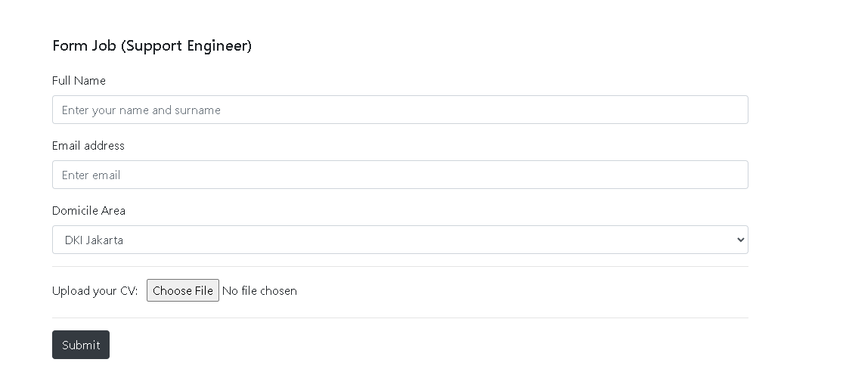

**Source Code**

<!DOCTYPE html>

<html lang="en">

<head >

    <meta charset="UTF-8">

    <meta name="viewport" content="width=device-width, initial-scale=1.0">

    <meta http-equiv="X-UA-Compatible" content="ie=edge">

    <title>Form Job 3</title>

  <link rel="stylesheet" href="css/style.css">

  <link rel="stylesheet" href="css/bootstrap.css">

*<!-- Icon-->*

  <link rel="stylesheet" href="https://cdnjs.cloudflare.com/ajax/libs/font-awesome/4.7.0/css/font-awesome.min.css">

*<!-- Memakai jQuery  -->*

  <script src="https://code.jquery.com/jquery-3.4.1.min.js"

    integrity="sha256-CSXorXvZcTkaix6Yvo6HppcZGetbYMGWSFlBw8HfCJo="crossorigin="anonymous"></script>

*<!-- Popper JS -->*

    <script src="https://cdnjs.cloudflare.com/ajax/libs/popper.js/1.14.7/umd/popper.min.js"></script>

*<!-- Latest compiled JavaScript -->*

    <script src="https://maxcdn.bootstrapcdn.com/bootstrap/4.3.1/js/bootstrap.min.js"></script>

    <script src="https://ajax.googleapis.com/ajax/libs/jquery/3.4.1/jquery.min.js"></script>

    <script src="https://maxcdn.bootstrapcdn.com/bootstrap/3.4.1/js/bootstrap.min.js"></script>

</head>

<style>

    h1 {

  font-size: 20px;

  margin-top: 24px;

  margin-bottom: 24px;

}

img {

height: 40px;

}

</style>

<body>

<nav class="navbar navbar-expand-md navbar-dark bg-dark">

        <a class="navbar-brand" href="home.html">

          <img src="images/logo2.png" width="150"  class="d-inline-block align-top" alt="">

          </a>

        <button class="navbar-toggler" type="button" data-toggle="collapse" data-target="#navbarNav" aria-controls="navbarNav" aria-expanded="false" aria-label="Toggle navigation">

        <span class="navbar-toggler-icon"></span>

        </button>

        <div class="collapse navbar-collapse " id="navbarNav">

          <ul class="nav">

          <li class="nav-item">

            <a class="nav-link" href="home.html"><i class="fa fa-fw fa-home"></i> Home <span class="sr-only">(current)</span></a>

          </li>

          <li class="nav-item dropdown">

            <a class="nav-link dropdown-toggle" href="#" id="navbardrop" data-toggle="dropdown" role="button" aria-haspopup="true" aria-expanded="false"><i class="fa fa-fw fa-car"></i>Car</a>

            <div class="dropdown-menu">

              <a class="dropdown-item" href="hyper.html"> Hyper Car</a>

              <a class="dropdown-item" href="sports.html"> Sports Car</a>

            </div>

          </li>

          <li class="nav-item">

            <a class="nav-link" href="about.html"><i class="fa fa-fw fa-location-arrow"></i>About Us</a>

          </li>

          </ul>

          <div class="navbar-nav ml-auto ">

            <a href="Login.html" class="nav-item nav-link" style="color:white;" ><i class="fa fa-fw fa-user-circle"></i>Login/SignUp</a>

          </div>

          </ul>

        </div>

      </nav>

    </div>

  </header>

*<!-- content -->*

   <div class="col-md-6 offset-md-3 mt-5">

    <h2><b>Support Engineer Job Description</b></h2>

    <br>

   <p>We are searching for an innovative, deadline-driven technical engineer to join our company. The technical engineer’s responsibilities include assisting Engineers with various tasks like design, construction, equipment installation, system configuration, maintenance, developing preventative maintenance plans, and providing customer support. You should also be able to troubleshoot systems, identify problems, and write up reports.

    To be successful as a technical engineer, you should be meticulous, efficient, and have sound knowledge of the relevant engineering discipline. Outstanding candidates are team players with exemplary problem-solving abilities.</p>

   <br>

   <br>

   <b>Support Engineer Responsibilities:</b>

   <br><br>

   <ul>

     <li>Bachelor’s degree or D3 in the relevant engineering discipline or similar.</li>

     <li>Additional certification or license may be required.</li>

     <li>Experience in a similar technical role recommended.</li>

     <li>Experience working as part of a team.</li>

     <li>Excellent attention to detail and problem-solving skills.</li>

     <li>Ability to follow instructions and collaborate with others.</li>

     </ul>

  <br>

  <h2><b>Support Engineer Requirements:</b></h2>

  <br>

  <ul>

  <li>Bachelor’s degree in the relevant engineering discipline or similar.</li>

  <li>Additional certification or license may be required.</li>

  <li>Experience in a similar technical role recommended.</li>

  <li>Experience working as part of a team.</li>

  <li>Excellent attention to detail and problem-solving skills.</li>

  <li>Ability to follow instructions and collaborate with others.</li>

  </ul>

  <br>

     <h1>Form Job (Support Engineer)</h1>

     <form accept-charset="UTF-8" action="https://getform.io/f/{your-form-endpoint-goes-here}" method="POST"  target="_blank">

       <div class="form-group">

         <label for="exampleInputName">Full Name</label>

         <input type="text" name="fullname" class="form-control" id="exampleInputName" placeholder="Enter your name and surname" required="required">

       </div>

       <div class="form-group">

         <label for="exampleInputEmail1" required="required">Email address</label>

         <input type="email" name="email" class="form-control" id="exampleInputEmail1" aria-describedby="emailHelp" placeholder="Enter email">

       </div>

       <div class="form-group">

         <label for="exampleFormControlSelect1">Domicile Area</label>

         <select class="form-control" id="exampleFormControlSelect1" name="platform" required="required">

           <option>DKI Jakarta</option>

           <option>Jawa Barat</option>

           <option>Jawa Timur</option>

         </select>

       </div>

       <hr>

       <div class="form-group mt-3">

         <label class="mr-2">Upload your CV:</label>

         <input type="file" name="file">

       </div>

       <hr>

       <button type="submit" class="btn btn-dark">Submit</button>

     </form>

 </div>

 <br>

 <br>

*<!-- akhir content -->*

*<!-- Footer -->*

<footer id="myFooter">

    <div class="container-fluid">

        <div class="row text-center">

            <div class="col-12 col-sm-6 col-md-3">

                <h1 class="logo" style="margin-top:30px;"></h1><img src="images/logo2.png" width="200px" >&nbsp;&nbsp;</img></h1>

            </div>

            <div class="col-12 col-sm-6 col-md-2">

                <h5>Get started</h5>

                <ul>

                    <li><a href="home.html">Home</a></li>

                    <li><a href="Login.html">Login</a></li>

                </ul>

            </div>

            <div class="col-12 col-sm-6 col-md-2">

                <h5>Our Company</h5>

                <ul>

                    <li><a href="about.html">About Us</a></li>

                    <li><a href="indexloker.html">Carrer</a></li>

                </ul>

            </div>

            <div class="col-md-3 social-networks">

                <div></div><a href="#" class="facebook"><i class="fa fa-facebook"></i></a><a href="#" class="twitter"><i class="fa fa-twitter"></i></a><a href="#"></i></a>

                <a href="about.html"><button  class="btn btn-primary" type="button" style="margin-top:20px;">Contact us</button></a>

            </div>

        </div>

        <div class="copyright bg-dark">

                <p><center>© 2016 Copyright McLaren &nbsp;<a href="#">Mohamad Adlian</a></center></p>

        </div>

    </div>

</footer>

</body>

</html>

**Bagian 4 (Form Job Office Boy)**

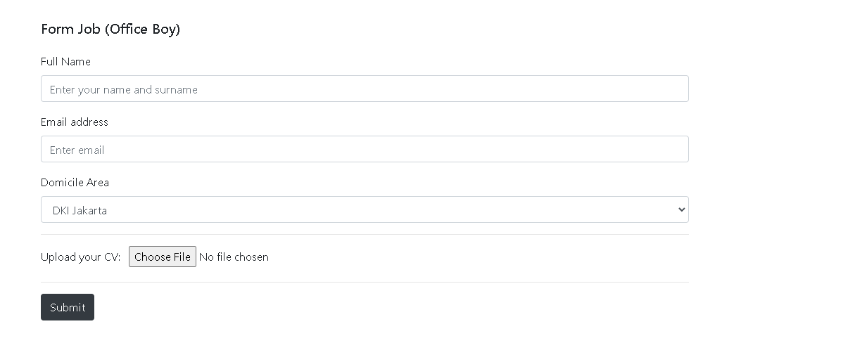

**Source Code**

<!DOCTYPE html>

<html lang="en">

<head >

    <meta charset="UTF-8">

    <meta name="viewport" content="width=device-width, initial-scale=1.0">

    <meta http-equiv="X-UA-Compatible" content="ie=edge">

    <title>Form Job 4</title>

  <link rel="stylesheet" href="css/style.css">

  <link rel="stylesheet" href="css/bootstrap.css">

*<!-- Icon-->*

  <link rel="stylesheet" href="https://cdnjs.cloudflare.com/ajax/libs/font-awesome/4.7.0/css/font-awesome.min.css">

*<!-- Memakai jQuery  -->*

  <script src="https://code.jquery.com/jquery-3.4.1.min.js"

    integrity="sha256-CSXorXvZcTkaix6Yvo6HppcZGetbYMGWSFlBw8HfCJo="crossorigin="anonymous"></script>

*<!-- Popper JS -->*

    <script src="https://cdnjs.cloudflare.com/ajax/libs/popper.js/1.14.7/umd/popper.min.js"></script>

*<!-- Latest compiled JavaScript -->*

    <script src="https://maxcdn.bootstrapcdn.com/bootstrap/4.3.1/js/bootstrap.min.js"></script>

    <script src="https://ajax.googleapis.com/ajax/libs/jquery/3.4.1/jquery.min.js"></script>

    <script src="https://maxcdn.bootstrapcdn.com/bootstrap/3.4.1/js/bootstrap.min.js"></script>

</head>

<style>

    h1 {

  font-size: 20px;

  margin-top: 24px;

  margin-bottom: 24px;

}

img {

height: 40px;

}

</style>

<body>

<nav class="navbar navbar-expand-md navbar-dark bg-dark">

        <a class="navbar-brand" href="home.html">

          <img src="images/logo2.png" width="150"  class="d-inline-block align-top" alt="">

          </a>

        <button class="navbar-toggler" type="button" data-toggle="collapse" data-target="#navbarNav" aria-controls="navbarNav" aria-expanded="false" aria-label="Toggle navigation">

        <span class="navbar-toggler-icon"></span>

        </button>

        <div class="collapse navbar-collapse " id="navbarNav">

          <ul class="nav">

          <li class="nav-item">

            <a class="nav-link" href="home.html"><i class="fa fa-fw fa-home"></i> Home <span class="sr-only">(current)</span></a>

          </li>

          <li class="nav-item dropdown">

            <a class="nav-link dropdown-toggle" href="#" id="navbardrop" data-toggle="dropdown" role="button" aria-haspopup="true" aria-expanded="false"><i class="fa fa-fw fa-car"></i>Car</a>

            <div class="dropdown-menu">

              <a class="dropdown-item" href="hyper.html"> Hyper Car</a>

              <a class="dropdown-item" href="sports.html"> Sports Car</a>

            </div>

          </li>

          <li class="nav-item">

            <a class="nav-link" href="about.html"><i class="fa fa-fw fa-location-arrow"></i>About Us</a>

          </li>

          </ul>

          <div class="navbar-nav ml-auto ">

            <a href="Login.html" class="nav-item nav-link" style="color:white;" ><i class="fa fa-fw fa-user-circle"></i>Login/SignUp</a>

          </div>

          </ul>

        </div>

      </nav>

    </div>

  </header>

*<!-- content -->*

   <div class="col-md-6 offset-md-3 mt-5">

    <h2><b>Office Boy Job Description</b></h2>

    <br>

   <p>A cleaner works to keep an organization tidy and orderly by taking stock of cleaning supplies and completing small cleaning jobs throughout the day like emptying trash cans, washing windows and scrubbing any dirty areas. They’re often given a certain set of tasks to complete before their shift and must have them finished by the end of the day. Cleaners are responsible for the safety of patrons or office workers by ensuring areas are properly sanitized and cleaning up any spills or messes that may harm customers or other employees.</p>

   <br>

   <br>

   <b>Office Boy Requirements:</b>

   <br><br>

   <ul>

    <li>Communication</li>

    <li>Interpersonal skills</li>

    <li>Proactivity</li>

    <li>The ability to work independently with minimal supervision</li>

    <li>The ability to follow health and safety standards</li>

    <li>Time management</li>

  </ul>

  <br>

     <h1>Form Job (Office Boy)</h1>

     <form accept-charset="UTF-8" action="https://getform.io/f/{your-form-endpoint-goes-here}" method="POST"  target="_blank">

       <div class="form-group">

         <label for="exampleInputName">Full Name</label>

         <input type="text" name="fullname" class="form-control" id="exampleInputName" placeholder="Enter your name and surname" required="required">

       </div>

       <div class="form-group">

         <label for="exampleInputEmail1" required="required">Email address</label>

         <input type="email" name="email" class="form-control" id="exampleInputEmail1" aria-describedby="emailHelp" placeholder="Enter email">

       </div>

       <div class="form-group">

         <label for="exampleFormControlSelect1">Domicile Area</label>

         <select class="form-control" id="exampleFormControlSelect1" name="platform" required="required">

           <option>DKI Jakarta</option>

           <option>Jawa Barat</option>

           <option>Jawa Timur</option>

         </select>

       </div>

       <hr>

       <div class="form-group mt-3">

         <label class="mr-2">Upload your CV:</label>

         <input type="file" name="file">

       </div>

       <hr>

       <button type="submit" class="btn btn-dark">Submit</button>

     </form>

 </div>

 <br>

 <br>

*<!-- akhir content -->*

*<!-- Footer -->*

<footer id="myFooter">

    <div class="container-fluid">

        <div class="row text-center">

            <div class="col-12 col-sm-6 col-md-3">

                <h1 class="logo" style="margin-top:30px;"></h1><img src="images/logo2.png" width="200px" >&nbsp;&nbsp;</img></h1>

            </div>

            <div class="col-12 col-sm-6 col-md-2">

                <h5>Get started</h5>

                <ul>

                    <li><a href="home.html">Home</a></li>

                    <li><a href="Login.html">Login</a></li>

                </ul>

            </div>

            <div class="col-12 col-sm-6 col-md-2">

                <h5>Our Company</h5>

                <ul>

                    <li><a href="about.html">About Us</a></li>

                    <li><a href="indexloker.html">Carrer</a></li>

                </ul>

            </div>

            <div class="col-md-3 social-networks">

                <div></div><a href="#" class="facebook"><i class="fa fa-facebook"></i></a><a href="#" class="twitter"><i class="fa fa-twitter"></i></a><a href="#"></i></a>

                <a href="about.html"><button  class="btn btn-primary" type="button" style="margin-top:20px;">Contact us</button></a>

            </div>

        </div>

        <div class="copyright bg-dark">

                <p><center>© 2016 Copyright McLaren &nbsp;<a href="#">Mohamad Adlian</a></center></p>

        </div>

    </div>

</footer>

</body>

</html>

**Bagian 5 (Form Job Data Analyst)**

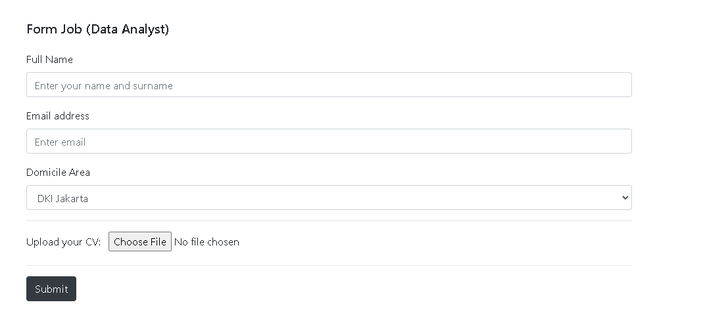

**Source Code**

<!DOCTYPE html>

<html lang="en">

<head >

    <meta charset="UTF-8">

    <meta name="viewport" content="width=device-width, initial-scale=1.0">

    <meta http-equiv="X-UA-Compatible" content="ie=edge">

    <title>Form Job 5</title>

  <link rel="stylesheet" href="css/style.css">

  <link rel="stylesheet" href="css/bootstrap.css">

*<!-- Icon-->*

  <link rel="stylesheet" href="https://cdnjs.cloudflare.com/ajax/libs/font-awesome/4.7.0/css/font-awesome.min.css">

*<!-- Memakai jQuery  -->*

  <script src="https://code.jquery.com/jquery-3.4.1.min.js"

    integrity="sha256-CSXorXvZcTkaix6Yvo6HppcZGetbYMGWSFlBw8HfCJo="crossorigin="anonymous"></script>

*<!-- Popper JS -->*

    <script src="https://cdnjs.cloudflare.com/ajax/libs/popper.js/1.14.7/umd/popper.min.js"></script>

*<!-- Latest compiled JavaScript -->*

    <script src="https://maxcdn.bootstrapcdn.com/bootstrap/4.3.1/js/bootstrap.min.js"></script>

    <script src="https://ajax.googleapis.com/ajax/libs/jquery/3.4.1/jquery.min.js"></script>

    <script src="https://maxcdn.bootstrapcdn.com/bootstrap/3.4.1/js/bootstrap.min.js"></script>

</head>

<style>

    h1 {

  font-size: 20px;

  margin-top: 24px;

  margin-bottom: 24px;

}

img {

height: 40px;

}

</style>

<body>

<nav class="navbar navbar-expand-md navbar-dark bg-dark">

        <a class="navbar-brand" href="home.html">

          <img src="images/logo2.png" width="150"  class="d-inline-block align-top" alt="">

          </a>

        <button class="navbar-toggler" type="button" data-toggle="collapse" data-target="#navbarNav" aria-controls="navbarNav" aria-expanded="false" aria-label="Toggle navigation">

        <span class="navbar-toggler-icon"></span>

        </button>

        <div class="collapse navbar-collapse " id="navbarNav">

          <ul class="nav">

          <li class="nav-item">

            <a class="nav-link" href="home.html"><i class="fa fa-fw fa-home"></i> Home <span class="sr-only">(current)</span></a>

          </li>

          <li class="nav-item dropdown">

            <a class="nav-link dropdown-toggle" href="#" id="navbardrop" data-toggle="dropdown" role="button" aria-haspopup="true" aria-expanded="false"><i class="fa fa-fw fa-car"></i>Car</a>

            <div class="dropdown-menu">

              <a class="dropdown-item" href="hyper.html"> Hyper Car</a>

              <a class="dropdown-item" href="sports.html"> Sports Car</a>

            </div>

          </li>

          <li class="nav-item">

            <a class="nav-link" href="about.html"><i class="fa fa-fw fa-location-arrow"></i>About Us</a>

          </li>

          </ul>

          <div class="navbar-nav ml-auto ">

            <a href="Login.html" class="nav-item nav-link" style="color:white;" ><i class="fa fa-fw fa-user-circle"></i>Login/SignUp</a>

          </div>

          </ul>

        </div>

      </nav>

    </div>

  </header>

*<!-- content -->*

   <div class="col-md-6 offset-md-3 mt-5">

    <h2><b>Data Analyst Job Description</b></h2>

    <br>

   <p>We are looking for a passionate certified Data Analyst. The successful candidate will turn data into information, information into insight and insight into business decisions.

    Data analyst responsibilities include conducting full lifecycle analysis to include requirements, activities and design. Data analysts will develop analysis and reporting capabilities. They will also monitor performance and quality control plans to identify improvements.

   </p>

   <p>Data analyst responsibilities include conducting full lifecycle analysis to include requirements, activities and design. Data analysts will develop analysis and reporting capabilities. They will also monitor performance and quality control plans to identify improvements.</p>

   <br>

   <b>Data Analyst Responsibilities:</b>

   <br><br>

   <ul>

    <li>Interpret data, analyze results using statistical techniques and provide ongoing reports</li>

    <li>Conducting experiments and evaluations to improve and innovate product designs.</li>

    <li>Develop and implement databases, data collection systems, data analytics and other strategies that optimize statistical efficiency and quality</li>

    <li>Acquire data from primary or secondary data sources and maintain databases/data systems</li>

    <li>Identify, analyze, and interpret trends or patterns in complex data sets</li>

    <li>Filter and “clean” data by reviewing computer reports, printouts, and performance indicators to locate and correct code problems</li>

    <li>Work with management to prioritize business and information needs</li>

    <li>Locate and define new process improvement opportunities</li>

  </ul>

  <br>

   <b>Data Analyst Requirements:</b>

   <br><br>

   <ul>

    <li>Proven working experience as a Data Analyst or Business Data Analyst</li>

    <li>Technical expertise regarding data models, database design development, data mining and segmentation techniques</li>

    <li>Strong knowledge of and experience with reporting packages (Business Objects etc), databases (SQL etc), programming (XML, Javascript, or ETL frameworks)</li>

    <li>Knowledge of statistics and experience using statistical packages for analyzing datasets (Excel, SPSS, SAS etc)</li>

    <li>Strong analytical skills with the ability to collect, organize, analyze, and disseminate significant amounts of information with attention to detail and accuracy</li>

    <li>Adept at queries, report writing and presenting findings</li>

    <li>BS in Mathematics, Economics, Computer Science, Information Management or Statistics</li>

  </ul>

     <br>

     <h1>Form Job (Data Analyst)</h1>

     <form accept-charset="UTF-8" action="https://getform.io/f/{your-form-endpoint-goes-here}" method="POST"  target="_blank">

       <div class="form-group">

         <label for="exampleInputName">Full Name</label>

         <input type="text" name="fullname" class="form-control" id="exampleInputName" placeholder="Enter your name and surname" required="required">

       </div>

       <div class="form-group">

         <label for="exampleInputEmail1" required="required">Email address</label>

         <input type="email" name="email" class="form-control" id="exampleInputEmail1" aria-describedby="emailHelp" placeholder="Enter email">

       </div>

       <div class="form-group">

         <label for="exampleFormControlSelect1">Domicile Area</label>

         <select class="form-control" id="exampleFormControlSelect1" name="platform" required="required">

           <option>DKI Jakarta</option>

           <option>Jawa Barat</option>

           <option>Jawa Timur</option>

         </select>

       </div>

       <hr>

       <div class="form-group mt-3">

         <label class="mr-2">Upload your CV:</label>

         <input type="file" name="file">

       </div>

       <hr>

       <button type="submit" class="btn btn-dark">Submit</button>

     </form>

 </div>

 <br>

 <br>

*<!-- akhir content -->*

*<!-- Footer -->*

<footer id="myFooter">

    <div class="container-fluid">

        <div class="row text-center">

            <div class="col-12 col-sm-6 col-md-3">

                <h1 class="logo" style="margin-top:30px;"></h1><img src="images/logo2.png" width="200px" >&nbsp;&nbsp;</img></h1>

            </div>

            <div class="col-12 col-sm-6 col-md-2">

                <h5>Get started</h5>

                <ul>

                    <li><a href="home.html">Home</a></li>

                    <li><a href="Login.html">Login</a></li>

                </ul>

            </div>

            <div class="col-12 col-sm-6 col-md-2">

                <h5>Our Company</h5>

                <ul>

                    <li><a href="about.html">About Us</a></li>

                    <li><a href="indexloker.html">Carrer</a></li>

                </ul>

            </div>

            <div class="col-md-3 social-networks">

                <div></div><a href="#" class="facebook"><i class="fa fa-facebook"></i></a><a href="#" class="twitter"><i class="fa fa-twitter"></i></a><a href="#"></i></a>

                <a href="about.html"><button  class="btn btn-primary" type="button" style="margin-top:20px;">Contact us</button></a>

            </div>

        </div>

        <div class="copyright bg-dark">

                <p><center>© 2016 Copyright McLaren &nbsp;<a href="#">Mohamad Adlian</a></center></p>

        </div>

    </div>

</footer>

</body>

</html>

**PENUTUP**

**3.1 Kesimpulan**

Dari paparan atau penjelasan di atas, maka penulis dapat menyimpulkan bahwa zaman sekarang teknologi sangan berkembang pesat sehingga kita harus mempelajarinya oleh karena itu dengan adanya teknologi segala sesuatu dapat dimudah kan . Mulai dari pekerjaan , pendidikan , bahkan dalam berjualan. Pembelajaran teknologi dengan membuat website dapat mengembangkan segala sesuatu yang solusi untuk membantu kebutuhan masyarakat dan dapat digunakan kedepannya.Dengan pembuatan website dapat membantu manusia dalam mendapatkan suatu informasi. Dengan demikian, desain web sederhana blog perusahan mobil ini di buat untuk membantu para pembeli untuk mencari informasi mobil McLaren .